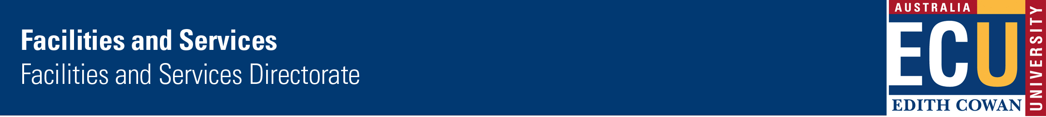
Work Instruction:  Legal and Other Requirements (Environmental) | Ref: 2.5.2.3

- Title:

Legal and Other Requirements (Environmental)

2. Purpose:

To identify and maintain a register of applicable legal and other requirements that are applicable to the environmental aspects of Facilities and Services.

3. Scope:

Activities, products and services under the direct control or influence of Facilities and Services within the scope of the Environmental Management System (EMS).

4. Definition/s:

Requirements: may be legal or other requirements that Edith Cowan University subscribes to.

Normal activities: those activities that occur during normal operations

5. Process:

5.1 Identify relevant legal/other requirements

Information sources may include: online publications, legal directories (ie: State Law Publishers), state and federal government alerts etc.

5.2 Assessing applicability

The applicability of requirements to the normal operations of Facilities and Services should be determined by asking the following questions:

- What are the key compliance elements of the environmental requirements? (ie energy use, waste production etc)

- Do these key elements fall within the scope of the environmental management system (EMS) or if not, could they still impact on the system directly or indirectly?

- Do these elements apply to the normal operating conditions and activities undertaken by Facilities and Services?

If the compliance elements fall within the scope of, or affect the EMS and relate to normal activities undertaken by Facilities and Services, then they are applicable to the EMS and should be added to the Environmental Risk and Compliance Register.

5.3 Aspect and Impact Register

The Coordinator, Environmental Systems will hold and maintain an up-to-date register of all environmental requirements that Facilities and Services subscribe to or is relevant to the normal operations of Facilities and Services.

6. Environmental Aspects:

Implicit within this Work Instruction

7. Risk Assessment:

Implicit within this Work Instruction

8. Records:

Relevant legal and other requirements will be recorded within the Environmental Risk and Compliance Register.

The environmental requirements with which Facilities and Services must comply will be reviewed at least every 12 months or as required. The date of the latest review will be listed on the Environmental Risk and Compliance Register.

The Register can be found under U:/Environmental Systems/Risk and Compliance

9. References:

Code: | 2.5.2.3
Owner: | Coordinator Environmental Systems
Approved By: | F&S Management Review Meeting
Date Approved: | May 2008
Amendment Dates:
Revision Date: | May 2011
Related Documents/Policies | Work Instruction: Environmental Aspects and Impacts at: http://www.ecu.edu.au/fas/procedures/listing.php?dvid=1

10. Contact Information:

Contact Person: | Belinda O’Brien
Telephone: | 6304 2032
Facsimile: | 6304 2787
Email address: | b.obrien@ecu.edu.au

