

**Edith Cowan University**

2024 ATAR Revision Seminar

**ATAR Mathematics Applications**

Curriculum Dot points

Examination and study tips

Revision notes Examination questions

Examination marker comments

Prepared and presented by

**Sean Ebert**

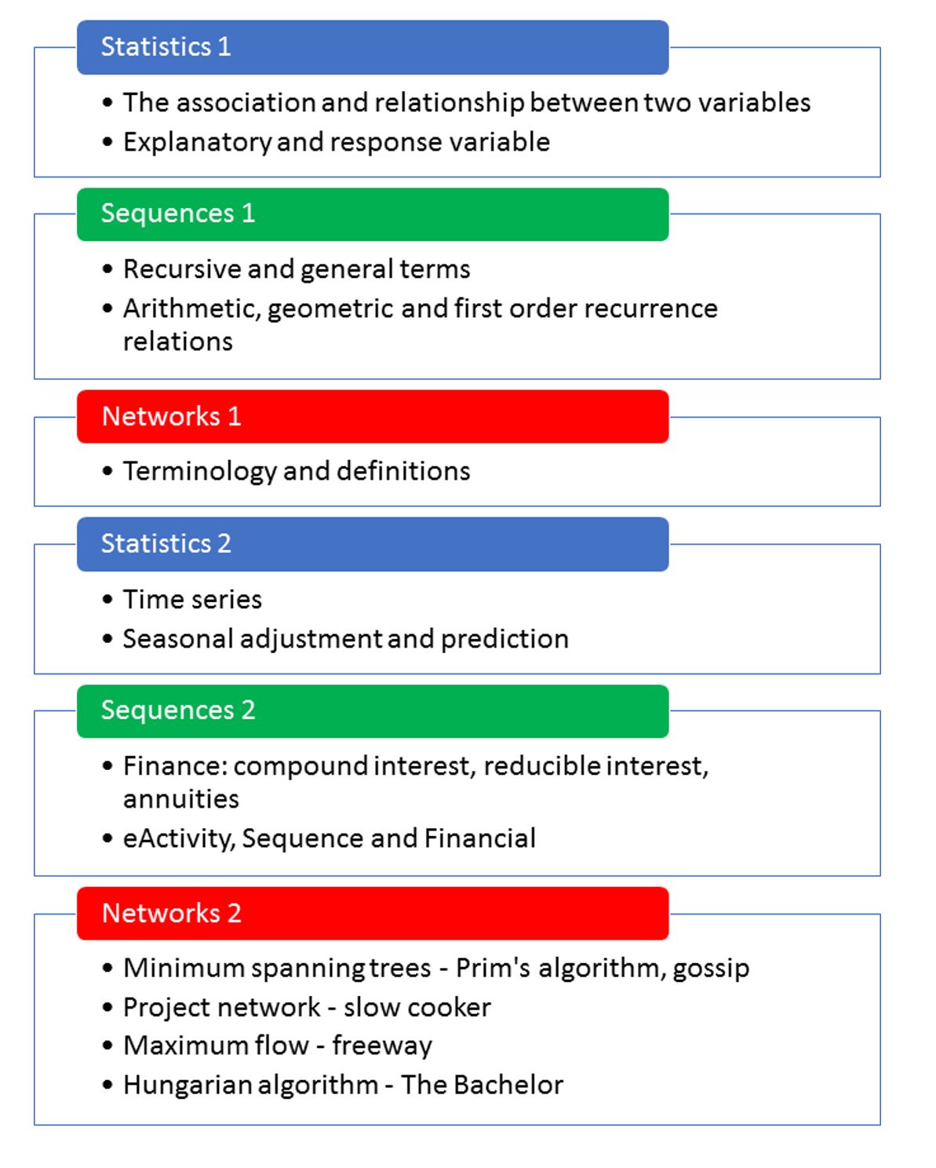

Mr Ebert

Six Big Ideas

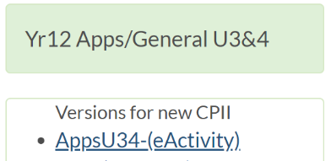eActivity – Communication Setup – Open – 3pt Cable

4 Hours – 5 minute breaks at the end of each hour

<https://charliewatson.com/casio/cpatar.php>

## 

## Applications Unit 3 Content

An understanding of the Year 11 content is assumed knowledge for students in Year 12. It is recommended that students studying Unit 3 and Unit 4 have completed Unit 1 and Unit 2.

This unit includes the knowledge, understandings and skills described below. This is the examinable content.

### Topic 3.1: Bivariate data analysis (20 hours)

**The statistical investigation process**

3.1.1 review the statistical investigation process: identify a problem; pose a statistical question; collect or obtain data; analyse data; interpret and communicate results

**Identifying and describing associations between two categorical variables**

3.1.2 construct two-way frequency tables and determine the associated row and column sums and percentages

3.1.3 use an appropriately percentaged two-way frequency table to identify patterns that suggest the presence of an association

3.1.4 describe an association in terms of differences observed in percentages across categories in a systematic and concise manner, and interpret this in the context of the data

**Identifying and describing associations between two numerical variables**

3.1.5 construct a scatterplot to identify patterns in the data suggesting the presence of an association

3.1.6 describe an association between two numerical variables in terms of direction (positive/negative), form (linear/non-linear) and strength (strong/moderate/weak)

3.1.7 calculate, using technology, and interpret the correlation coefficient (*r*) to quantify the strength of a linear association

**Fitting a linear model to numerical data**

* + 1. identify the response variable and the explanatory variable for primary and secondary data
    2. use a scatterplot to identify the nature of the relationship between variables
    3. model a linear relationship by fitting a least-squares line to the data
    4. use a residual plot to assess the appropriateness of fitting a linear model to the data
    5. interpret the intercept and slope of the fitted line

3.1.13 use the coefficient of determination to assess the strength of a linear association in terms of the explained variation

* + 1. use the equation of a fitted line to make predictions

3.1.15 distinguish between interpolation and extrapolation when using the fitted line to make predictions, recognising the potential dangers of extrapolation

3.1.16 write up the results of the above analysis in a systematic and concise manner

**Association and causation**

3.1.17 recognise that an observed association between two variables does not necessarily mean that there is a causal relationship between them

3.1.18 identify possible non-causal explanations for an association, including coincidence and confounding due to a common response to another variable, and communicate these explanations in a systematic and concise manner

**The data investigation process**

3.1.19 implement the statistical investigation process to answer questions that involve identifying, analysing and describing associations between two categorical variables or between two numerical variables

### Topic 3.2: Growth and decay in sequences (15 hours)

**The arithmetic sequence**

* + 1. use recursion to generate an arithmetic sequence

3.2.2 display the terms of an arithmetic sequence in both tabular and graphical form and demonstrate that arithmetic sequences can be used to model linear growth and decay in discrete situations

3.2.3 deduce a rule for the term of a particular arithmetic sequence from the pattern of the terms in an arithmetic sequence, and use this rule to make predictions

3.2.4 use arithmetic sequences to model and analyse practical situations involving linear growth or decay

**The geometric sequence**

* + 1. use recursion to generate a geometric sequence

3.2.6 display the terms of a geometric sequence in both tabular and graphical form and demonstrate that geometric sequences can be used to model exponential growth and decay in discrete situations

3.2.7 deduce a rule for the term of a particular geometric sequence from the pattern of the terms in the sequence, and use this rule to make predictions

3.2.8 use geometric sequences to model and analyse (numerically, or graphically only) practical problems involving geometric growth and decay

**Sequences generated by first-order linear recurrence relations**

3.2.9 use a general first-order linear recurrence relation to generate the terms of a sequence and to display it in both tabular and graphical form

3.2.10 generate a sequence defined by a first-order linear recurrence relation that gives long term increasing, decreasing or steady-state solutions

3.2.11 use first-order linear recurrence relations to model and analyse (numerically or graphically only) practical problems

### Topic 3.3: Graphs and networks (20 hours)

**The definition of a graph and associated terminology**

3.3.1 demonstrate the meanings of, and use, the terms: graph, edge, vertex, loop, degree of a vertex, subgraph, simple graph, complete graph, bipartite graph, directed graph (digraph), arc, weighted graph, and network

3.3.2 identify practical situations that can be represented by a network, and construct such networks

3.3.3 construct an adjacency matrix from a given graph or digraph and use the matrix to solve associated problems

**Planar graphs**

* + 1. demonstrate the meanings of, and use, the terms: planar graph and face

3.3.5 apply Euler’s formula, to solve problems relating to planar graphs.

**Paths and cycles**

3.3.6 demonstrate the meanings of, and use, the terms: walk, trail, path, closed walk, closed trail, cycle, connected graph, and bridge

3.3.7 investigate and solve practical problems to determine the shortest path between two vertices in a weighted graph (by trial-and-error methods only)

3.3.8 demonstrate the meanings of, and use, the terms: Eulerian graph, Eulerian trail, semi-Eulerian graph, semi-Eulerian trail and the conditions for their existence, and use these concepts to investigate and solve practical problems

3.3.9 demonstrate the meanings of, and use, the terms: Hamiltonian graph and semi-Hamiltonian graph, and use these concepts to investigate and solve practical problems

## Applications Unit 4 Content

This unit builds on the content covered in Unit 3.

This unit includes the knowledge, understandings and skills described below. This is the examinable content.

### Topic 4.1: Time series analysis (15 hours)

**Describing and interpreting patterns in time series data**

* + 1. construct time series plots

4.1.2 describe time series plots by identifying features such as trend (long term direction), seasonality (systematic, calendar-related movements), and irregular fluctuations (unsystematic, short term fluctuations), and recognise when there are outliers

**Analysing time series data**

4.1.3 smooth time series data by using a simple moving average, including the use of spreadsheets to implement this process

* + 1. calculate seasonal indices by using the average percentage method

4.1.5 deseasonalise a time series by using a seasonal index, including the use of spreadsheets to implement this process

* + 1. fit a least-squares line to model long-term trends in time series data

4.1.7 predict from regression lines, making seasonal adjustments for periodic data

**The data investigation process**

4.1.8 implement the statistical investigation process to answer questions that involve the analysis of time series data

### Topic 4.2: Loans, investments and annuities (20 hours)

**Compound interest loans and investments**

4.2.1 use a recurrence relation to model a compound interest loan or investment and investigate (numerically or graphically) the effect of the interest rate and the number of compounding periods on the future value of the loan or investment

4.2.2 calculate the effective annual rate of interest and use the results to compare investment returns and cost of loans when interest is paid or charged daily, monthly, quarterly or six-monthly

4.2.3 with the aid of a calculator or computer-based financial software, solve problems involving compound interest loans, investments and depreciating assets

**Reducing balance loans (compound interest loans with periodic repayments)**

4.2.4 use a recurrence relation to model a reducing balance loan and investigate (numerically or graphically) the effect of the interest rate and repayment amount on the time taken to repay the loan

4.2.5 with the aid of a financial calculator or computer-based financial software, solve problems involving reducing balance loans

**Annuities and perpetuities (compound interest investments with periodic payments made from the investment)**

4.2.6 use a recurrence relation to model an annuity, and investigate (numerically or graphically) the effect of the amount invested, the interest rate, and the payment amount on the duration of the annuity

4.2.7 with the aid of a financial calculator or computer-based financial software, solve problems involving annuities (including perpetuities as a special case)

### Topic 4.3: Networks and decision mathematics (20 hours)

**Trees and minimum connector problems**

* + 1. identify practical examples that can be represented by trees and spanning trees

4.3.2 identify a minimum spanning tree in a weighted connected graph, either by inspection or by using Prim’s algorithm

4.3.3 use minimal spanning trees to solve minimal connector problems

**Project planning and scheduling using critical path analysis (CPA)**

4.3.4 construct a network to represent the durations and interdependencies of activities that must be completed during the project

4.3.5 use forward and backward scanning to determine the earliest starting time (EST) and latest starting times (LST) for each activity in the project

* + 1. use ESTs and LSTs to locate the critical path(s) for the project
    2. use the critical path to determine the minimum time for a project to be completed

4.3.8 calculate float times for non-critical activities

**Flow networks**

4.3.9 solve small-scale network flow problems, including the use of the ‘maximum flow-minimum cut’ theorem

**Assignment problems**

* + 1. use a bipartite graph and/or its tabular or matrix form to represent an assignment/ allocation problem
    2. determine the optimum assignment(s), by inspection for small-scale problems, or by use of the Hungarian algorithm for larger problems

The SIX big ideas in the Year 12 Applications course are:

**1. Data Analysis**

**The statistical investigation process**

3.1.1 review the statistical investigation process: identify a problem; pose a statistical question; collect or obtain data; analyse data; interpret and communicate results

**Identifying and describing associations between two categorical variables**

3.1.2 construct two-way frequency tables and determine the associated row and column sums and percentages

3.1.3 use an appropriately percentaged two-way frequency table to identify patterns that suggest the presence of an association

3.1.4 describe an association in terms of differences observed in percentages across categories in a systematic and concise manner, and interpret this in the context of the data

**EXAMPLE 1**

In 2015 at a coeducational school in Perth, 180 students received an ATAR. Sixty percent of the ATAR students were female and of these 28 received a score above 90, 70 between 80 and 90 and the rest less than 80. Of the males, 12 scored above 90 and half scored less than 80.

Use the syllabus reference points above to determine whether an association exists.

|  |  |  |  |  |
| --- | --- | --- | --- | --- |
|  |  |  |  |  |
|  |  |  |  |  |
|  |  |  |  |  |
|  |  |  |  |  |

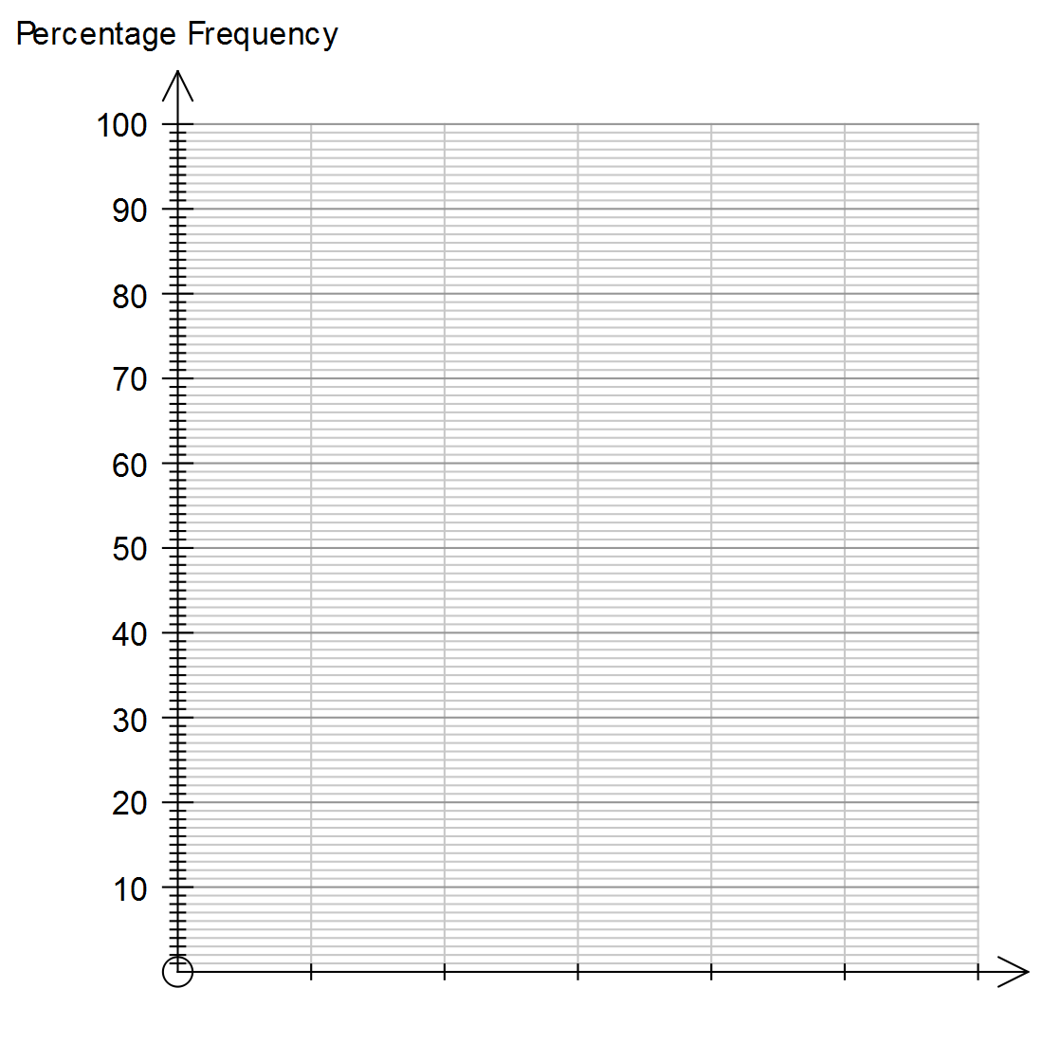

**Identifying and describing associations between two numerical variables**

3.1.5 construct a scatterplot to identify patterns in the data suggesting the presence of an association

3.1.6 describe an association between two numerical variables in terms of direction (positive/negative), form (linear/non-linear) and strength (strong/moderate/weak)

3.1.7 calculate, using technology, and interpret the correlation coefficient (*r*) to quantify the strength of a linear association

**EXAMPLE 2**

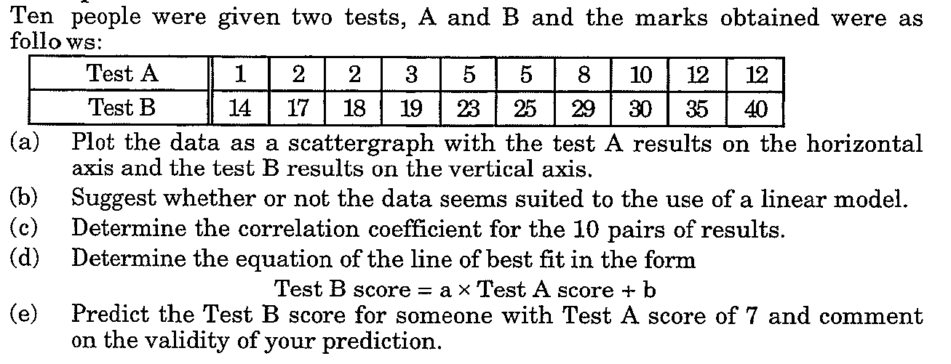

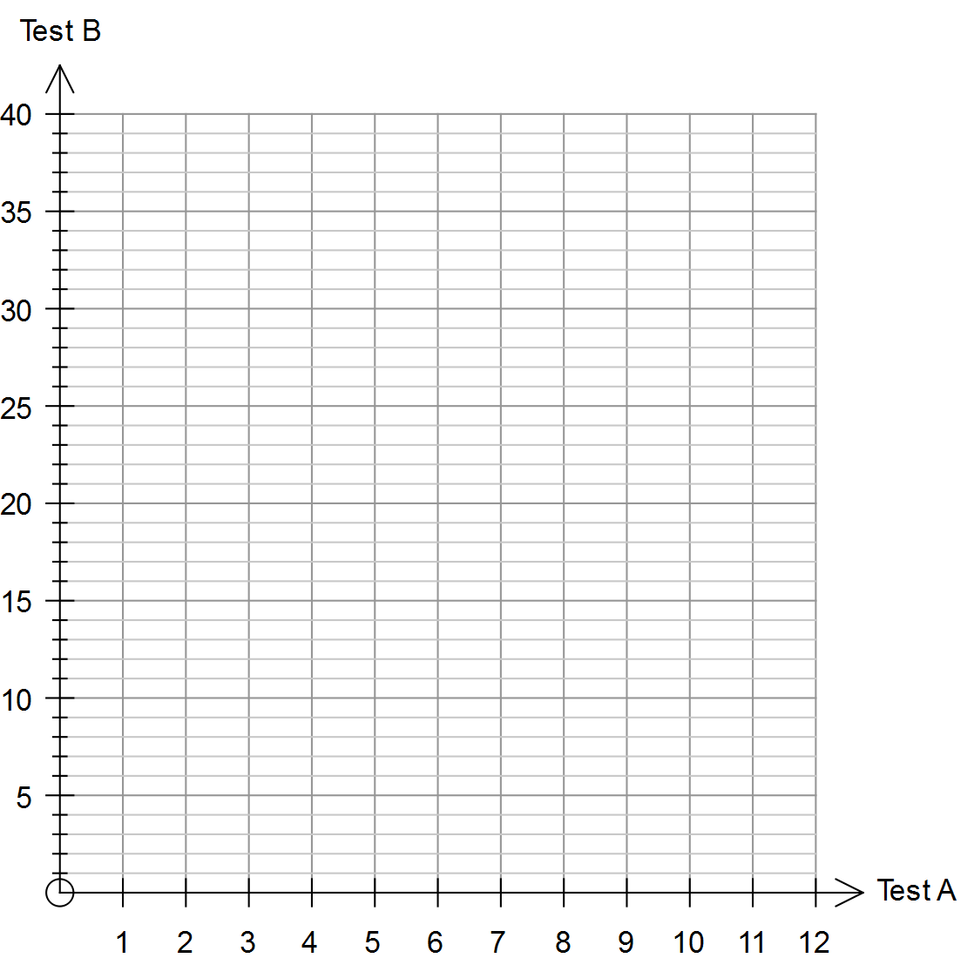

**Fitting a linear model to numerical data**

* + 1. identify the response variable and the explanatory variable for primary and secondary data
    2. use a scatterplot to identify the nature of the relationship between variables
    3. model a linear relationship by fitting a least-squares line to the data

**EXAMPLE 3**

The weight of abalone in kilograms caught off Trigg Beach and the daily temperature (°C) is shown below.

|  |  |  |  |  |  |  |  |  |  |  |
| --- | --- | --- | --- | --- | --- | --- | --- | --- | --- | --- |
| **Daily Temp.** (°C) | 26 | 27.2 | 27.9 | 28.4 | 30.5 | 32.1 | 34 | 36.3 | 37 | 33.5 |
| **Catch (kg)** | 39.9 | 36 | 32.5 | 31 | 28 | 26 | 24 | 23.1 | 23 | 25 |

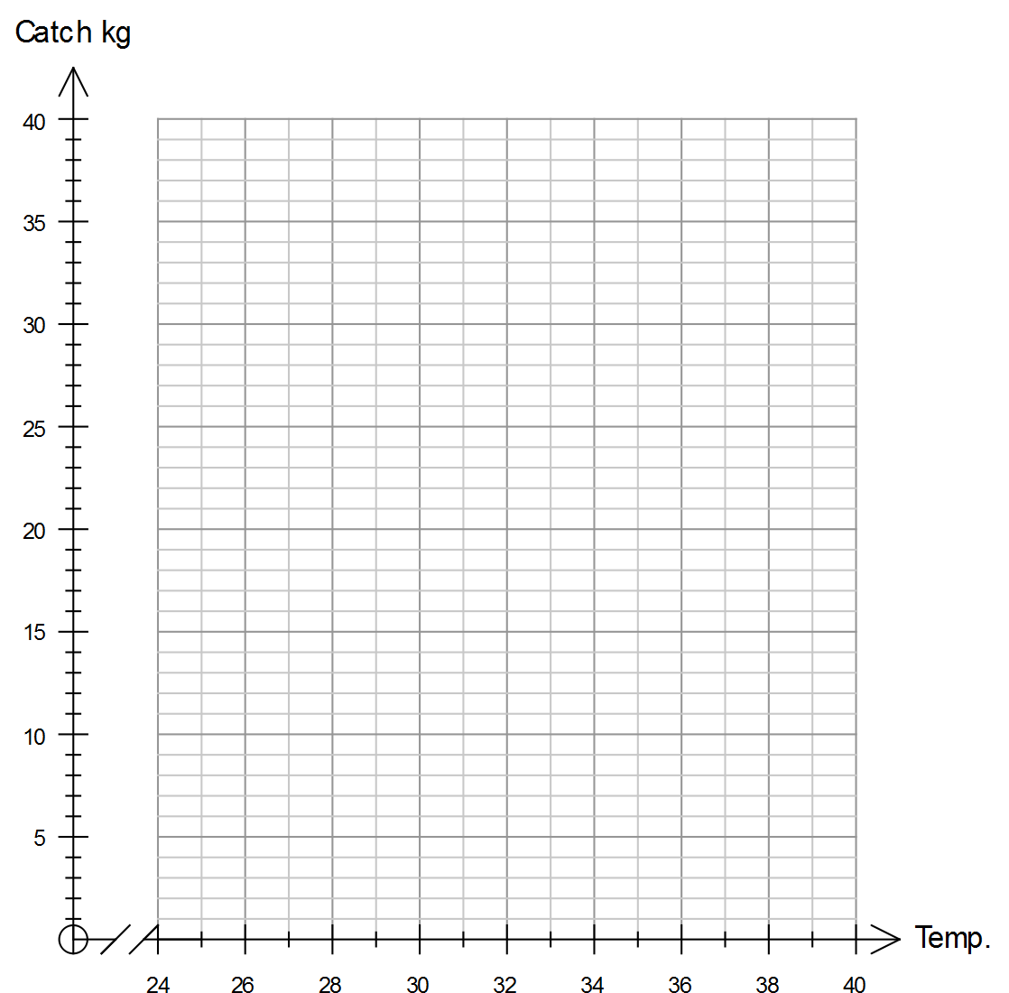

Comment on the relationship between the two variables using the graph.

Comment on the relationship between the two variables using the correlation coefficient, r.

Determine and draw a line of best fit and hence predict the catch for a 40°C day. Explain how confident you are with your prediction.

What would a residual plot tell you about the relationship between the two variables?

3.1.11 use a residual plot to assess the appropriateness of fitting a linear model to the data

3.1.12 interpret the intercept and slope of the fitted line

3.1.13 use the coefficient of determination to assess the strength of a linear association in terms of the explained variation

3.1.14 use the equation of a fitted line to make predictions

3.1.15 distinguish between interpolation and extrapolation when using the fitted line to make predictions, recognising the potential dangers of extrapolation

3.1.16 write up the results of the above analysis in a systematic and concise manner

**EXAMPLE 4**

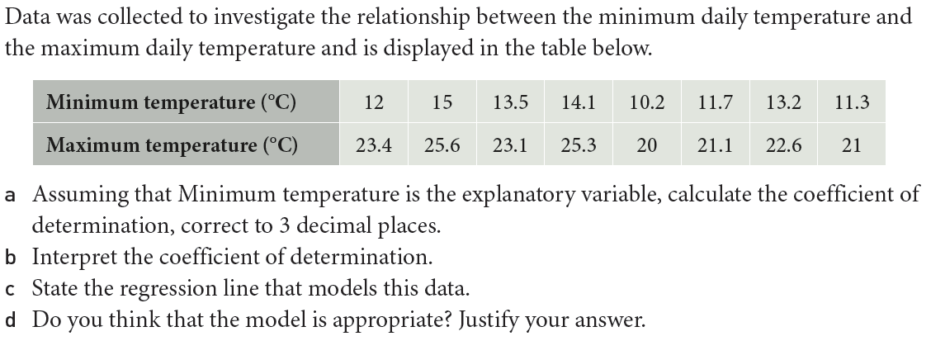

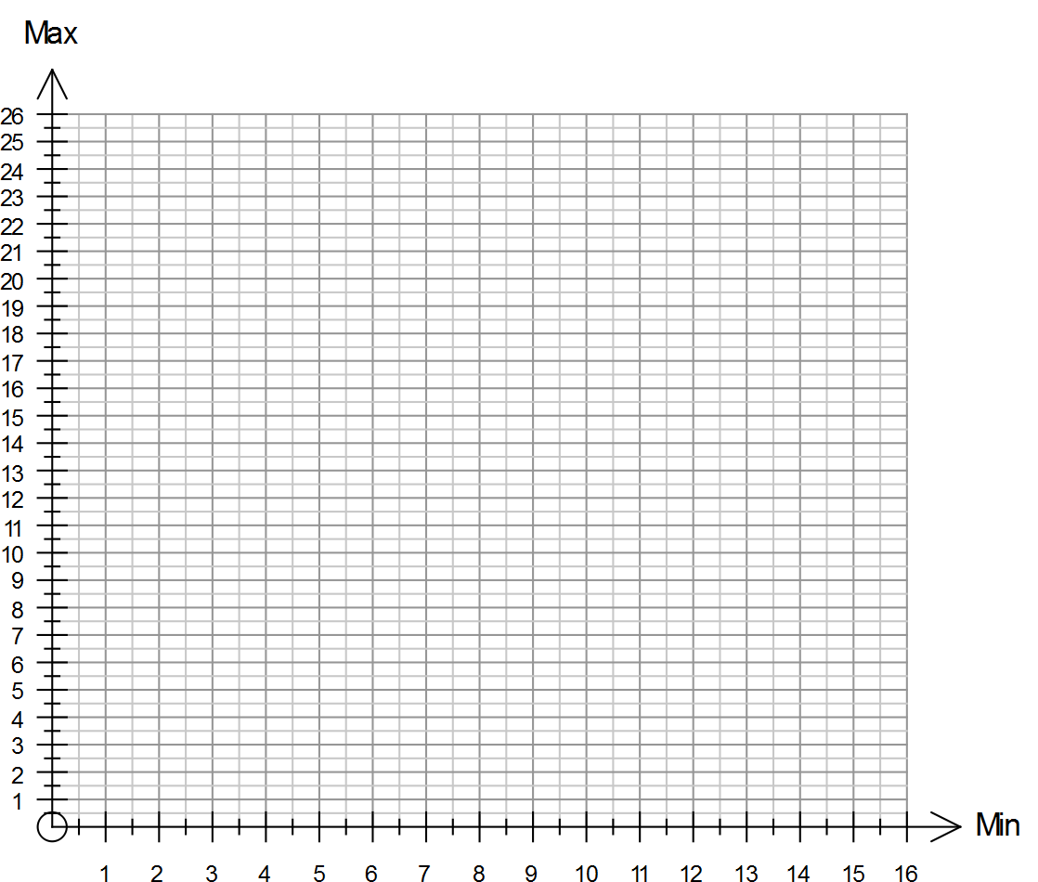

**EXAMPLE 5**

|  |  |  |  |  |  |  |  |
| --- | --- | --- | --- | --- | --- | --- | --- |
| **x** | 3 | 5 | 6 | 1 | 8 | 7 | 1 |
| **y** | 7 | 9 | 7 | 12 | 2 | 4 | 2 |
|  |  |  |  |  |  |  |  |
|  |  |  |  |  |  |  |  |

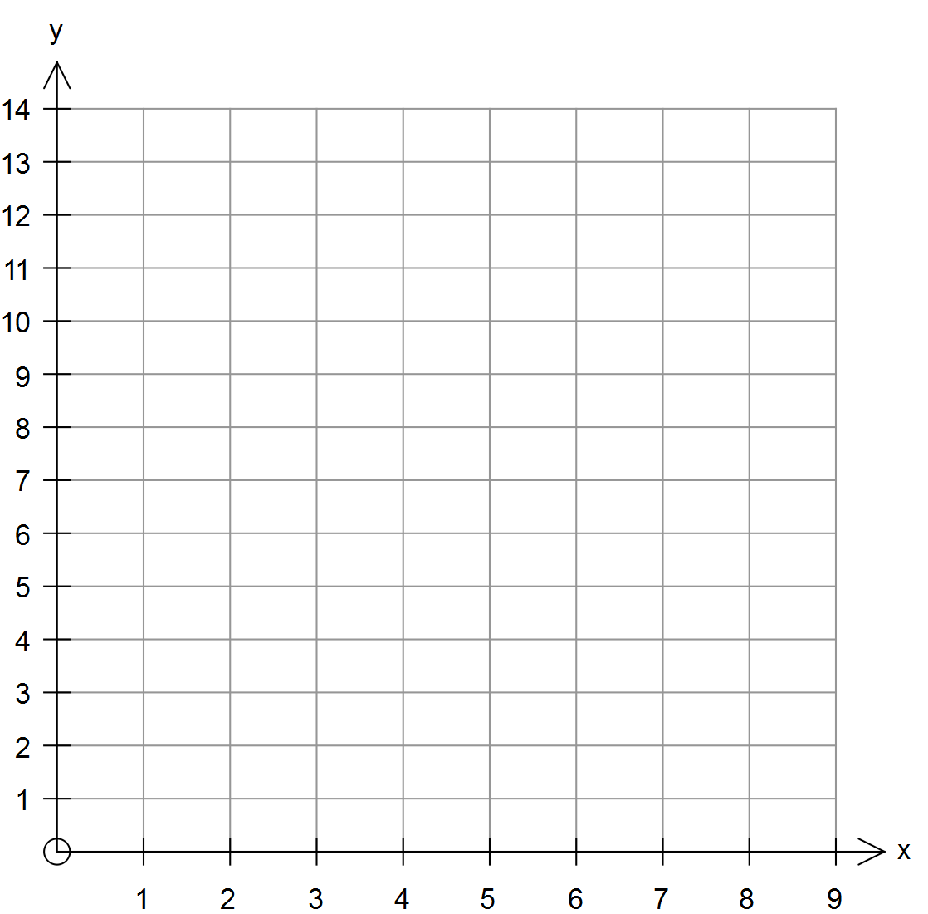

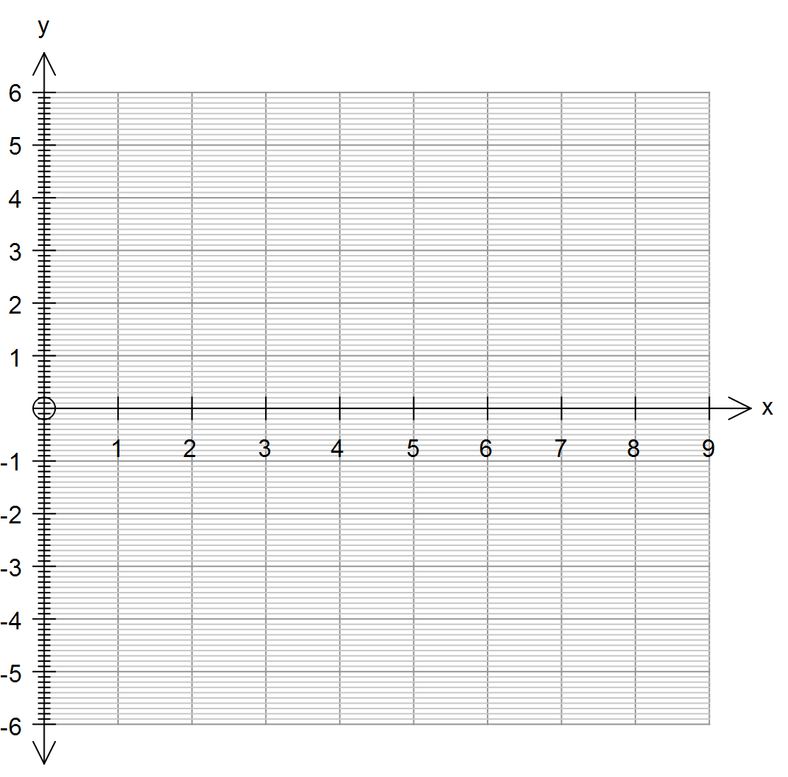

**Association and causation**

3.1.17 recognise that an observed association between two variables does not necessarily mean that there is a causal relationship between them

3.1.18 identify possible non-causal explanations for an association, including coincidence and confounding due to a common response to another variable, and communicate these explanations in a systematic and concise manner

**The data investigation process**

3.1.19 implement the statistical investigation process to answer questions that involve identifying, analysing and describing associations between two categorical variables or between two numerical variables

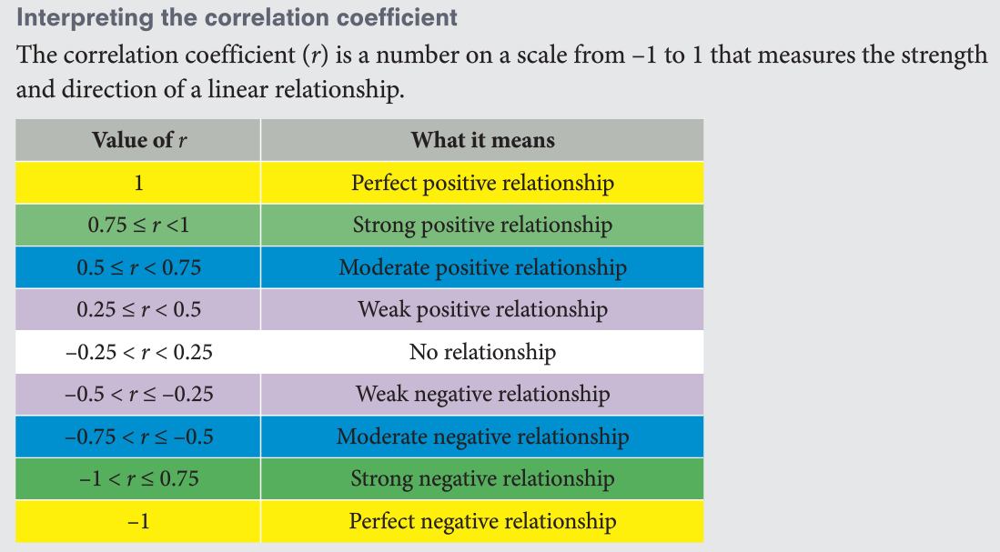

**Describing and interpreting patterns in time series data**

* + 1. construct time series plots

4.1.2 describe time series plots by identifying features such as trend (long term direction), seasonality (systematic, calendar-related movements), and irregular fluctuations (unsystematic, short term fluctuations), and recognise when there are outliers

**EXAMPLE 6**

|  |  |  |  |  |
| --- | --- | --- | --- | --- |
| **Time Period** | **Quarter** | **Ice Cream Sales**  **(000s kg)** |  | Construct a time series plot on the axes below.  **Trend**  **Seasonality**  **Irregular fluctuations** |
| **1** | Mar-13 | 2.1 |  |
| **2** | Jun-13 | 1.6 |  |
| **3** | Sep-13 | 3.0 |  |
| **4** | Dec-13 | 3.1 |  |
| **5** | Mar-14 | 3.2 |  |
| **6** | Jun-14 | 2.2 |  |
| **7** | Sep-14 | 4.0 |  |  |
| **8** | Dec-14 | 4.1 |  |
| **9** | Mar-15 | 4.1 |  |
| **10** | Jun-15 | 3.0 |  |
| **11** | Sep-15 | 5.5 |  |
| **12** | Dec-15 | 5.7 |  |



**Analysing time series data**

4.1.3 smooth time series data by using a simple moving average, including the use of spreadsheets to implement this process

* + 1. calculate seasonal indices by using the average percentage method

4.1.5 deseasonalise a time series by using a seasonal index, including the use of spreadsheets to implement this process

* + 1. fit a least-squares line to model long-term trends in time series data

4.1.7 predict from regression lines, making seasonal adjustments for periodic data

**The data investigation process**

4.1.8 implement the statistical investigation process to answer questions that involve the analysis of time series data

**EXAMPLE 7**

1. Sales figures of the ‘HOMER’ automobile are shown in the table and graph below.

|  |  |  |  |
| --- | --- | --- | --- |
| Time Period (t) | Year | Sales (000’s) | **A** pt moving Average |
| 1 | 1992 | 6.3 |  |
| 2 | 1993 | 2.1 | **B** |
| 3 | 1994 | 7.5 | **C** |
| 4 | 1995 | 6.8 | **D** |
| 5 | 1996 | 3 | 5.9 |
| 6 | 1997 | 8 | 6.0 |
| 7 | 1998 | 6.9 | 6.1 |
| 8 | 1999 | 3.4 | 6.4 |
| 9 | 2000 | 9 | **E** |
| 10 | 2001 | 8 | 7.5 |
| 11 | 2002 | 5.5 | 7.4 |
| 12 | 2003 | **F** |  |

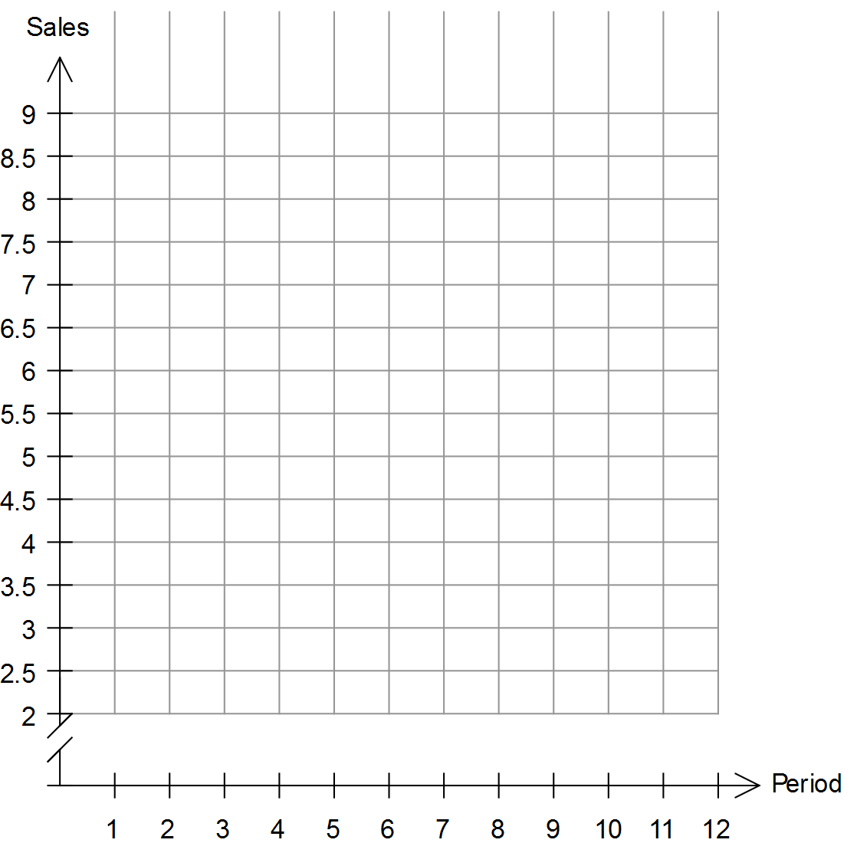

a) Plot the known sales figures on the axes.

[1]

b) Comment on the seasonality of the data.

[2]

c) What is the period of the data?

[1]

d) Determine the values of **A**, **B**, **C**, **D**, **E** and **F** in the table above.

e) Plot the moving averages on the axes above. Describe the trend of the data.

**EXAMPLE 8**

Saturday Muffin sales at Café de Pascal are shown below:

|  |  |  |  |  |  |  |
| --- | --- | --- | --- | --- | --- | --- |
| **Date** | **Shift** | **Period** | **Muffins sold** | **3pt MA** | **Percentage of Daily Mean** | **Seasonally adjusted** |
| 2 July | Morning | 1 | 145 |  |  |  |
| Afternoon | 2 | 112 |  |  |  |
| Night | 3 | 34 |  |  |  |
| 9 July | Morning | 4 | 137 |  |  |  |
| Afternoon | 5 | 121 |  |  |  |
| Night | 6 | 27 |  |  |  |
| 16 July | Morning | 7 | 129 |  |  |  |
| Afternoon | 8 | 118 |  |  |  |
| Night | 9 | 24 |  |  |  |

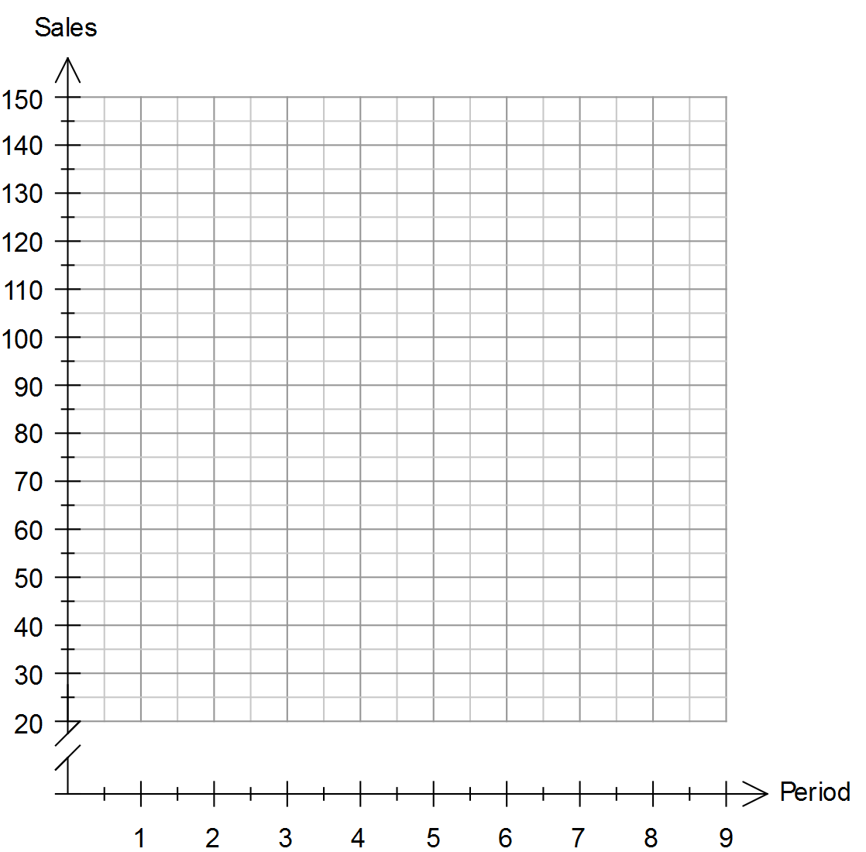d) Complete all values in the table above.

a) Plot the muffin sales figures on the axes.

[1]

b) Comment on the seasonality of the data.

[2]

c) What is the period of the data?

[1]

**Average for each cycle**

|  |  |  |  |
| --- | --- | --- | --- |
| **Cycle** |  |  |  |
| **Average** |  |  |  |

**Percentage of daily mean**

**Seasonal index**

|  |  |
| --- | --- |
| Morning |  |
| Afternoon |  |
| Night |  |

**Seasonally adjusted figures**

**2. Sequences and Finance**

**The arithmetic sequence**

* + 1. use recursion to generate an arithmetic sequence

3.2.2 display the terms of an arithmetic sequence in both tabular and graphical form and demonstrate that arithmetic sequences can be used to model linear growth and decay in discrete situations

3.2.3 deduce a rule for the term of a particular arithmetic sequence from the pattern of the terms in an arithmetic sequence, and use this rule to make predictions

3.2.4 use arithmetic sequences to model and analyse practical situations involving linear growth or decay

**EXAMPLE 9**

**Resource Free Section**

1. For each of the following sequences, find the first five terms (DRAW A TABLE):

a) 

[4]

|  |  |
| --- | --- |
| n |  |
| tn |  |

b) 

[4]

c) 

[4]

d) 

[4]

2. For each of the following, determine a recursive equation, a general equation for the nth term and hence determine T10 and T100.

1. 5, 9, 13, 17, …

[6]

1. 50, 40, 30, 20, …

[6]

1. 4, -2, -8, -14, …

[6]

3. Show clearly if 151 a term in the sequence -5, 1, 7, 13, …? If so, which term?

[4]

4. Which is the first term of the sequence 3, 11, 19, … that is larger than 500? What is the term?

[4]

**The geometric sequence**

* + 1. use recursion to generate a geometric sequence

3.2.6 display the terms of a geometric sequence in both tabular and graphical form and demonstrate that geometric sequences can be used to model exponential growth and decay in discrete situations

3.2.7 deduce a rule for the term of a particular geometric sequence from the pattern of the terms in the sequence, and use this rule to make predictions

3.2.8 use geometric sequences to model and analyse (numerically, or graphically only) practical problems involving geometric growth and decay

**EXAMPLE 10**

1. For each of the following sequences, determine

1. the first five terms,
2. whether the sequence is arithmetic, geometric or neither,
3. a general term (if the sequence is arithmetic or geometric)
4. T10 using the general term
5. The sum of the first 10 terms, S10.

a) 

[5]

|  |  |
| --- | --- |
| n |  |
| tn |  |

b) 

[5]

c) 

[5]

d) 50, 25, 12.5, …

[5]

e) 4, -6, 9, …

[5]

2. A geometric sequence has a second term of 30 and a fifth term of 101.25.

Determine a general term for the sequence.

[4]

**Sequences generated by first-order linear recurrence relations**

3.2.9 use a general first-order linear recurrence relation to generate the terms of a sequence and to display it in both tabular and graphical form

3.2.10 generate a sequence defined by a first-order linear recurrence relation that gives long term increasing, decreasing or steady-state solutions

3.2.11 use first-order linear recurrence relations to model and analyse (numerically or graphically only) practical problems

**EXAMPLE 11**

Three recursion relations are given below.



1. Determine the first 5 terms of each sequence.

[3]

1. Only one of the recursion relations has a steady-state solution. Explain clearly which one it is and why the others do not have a steady-state solution.

[2]

1. Determine the steady-state solution for the appropriate recursion relation above.

[3]

2. (5 marks)

A grain store has 4 tonnes of wheat and an extra 3 tonnes is added every month. If 25% of the grain is removed every month, determine the amount of grain that will eventually remain in the grain store.

**Compound interest loans and investments**

4.2.1 use a recurrence relation to model a compound interest loan or investment and investigate (numerically or graphically) the effect of the interest rate and the number of compounding periods on the future value of the loan or investment

4.2.2 calculate the effective annual rate of interest and use the results to compare investment returns and cost of loans when interest is paid or charged daily, monthly, quarterly or six-monthly

4.2.3 with the aid of a calculator or computer-based financial software, solve problems involving compound interest loans, investments and depreciating assets

**EXAMPLE 12**

1. Write recurrence relations for each of the following situations:

a) $40,000 invested at interest rate of 3.5% p.a., compounded yearly.

[2]

b) $62,500 invested at interest rate of 4.25% p.a., compounded monthly.

[2]

c) $850 invested at interest rate of 2.34% p.a., compounded 3 monthly.

[2]

2. Determine the amount of interest earned in each of the following scenarios by first writing a recurrence relation.

a) $80,000 invested for 10 years at an interest rate of 4.3% p.a., compounded yearly.

[3]

b) $350,000 invested for 40 months at an interest rate of 6.15% p.a., compounded monthly.

[3]

3. Judy invests $120,000 at 5.1% p.a. for 16 years, compounded six monthly.

Show working to answer:

a) How much is the investment worth after 16 years?

[3]

b) What is the difference between what the investment earns in the last four years, compared to the first twelve years?

[3]

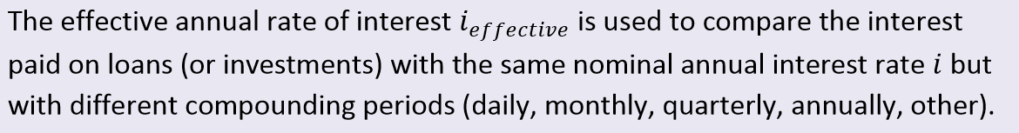

What does this mean?

Complete the following table, using the eActivity, when $100 is invested for one year for different compounding periods.

|  |  |  |  |  |  |  |  |
| --- | --- | --- | --- | --- | --- | --- | --- |
|  | n | 5% p.a. | Effective | 6.5% p.a. | Effective | 11% p.a. | Effective |
| Annual |  |  |  |  |  |  |  |
| 6 Monthly |  |  |  |  |  |  |  |
| Quarterly |  |  |  |  |  |  |  |
| Monthly |  |  |  |  |  |  |  |
| Weekly |  |  |  |  |  |  |  |
| Daily |  |  |  |  |  |  |  |

**Reducing balance loans (compound interest loans with periodic repayments)**

4.2.4 use a recurrence relation to model a reducing balance loan and investigate (numerically or graphically) the effect of the interest rate and repayment amount on the time taken to repay the loan

4.2.5 with the aid of a financial calculator or computer-based financial software, solve problems involving reducing balance loans

**EXAMPLE 13**

1. A loan is repaid according to the schedule below:

|  |  |  |  |  |  |
| --- | --- | --- | --- | --- | --- |
| **Period** | **Date** | **Owing** | **Interest** | **Repayment** | **Owing** |
| 1 | Jan-16 | $430,000.00 | $ 15,480.00 | $ 32,000.00 | $ 413,480.00 |
| 2 | Jul-16 | $413,480.00 | $ 14,885.28 | $ 32,000.00 | $ 396,365.28 |
| 3 | Jan-17 | $396,365.28 | $ 14,269.15 | $ 32,000.00 | $ 378,634.43 |
| 4 | Jul-17 | $378,634.43 | $ 13,630.84 | $ 32,000.00 | $ 360,265.27 |
| 5 | Jan-18 | $360,265.27 | $ 12,969.55 | $ 32,000.00 | $ 341,234.82 |

1. Write a recurrence relation for this mortgage.

[2]

1. When is the mortgage paid off?

[1]

1. Show working to determine the final repayment.

[2]

1. Determine the amount of interest paid on the loan.

[2]

1. If all other parameters stay the same, how much should be repaid per time period so that the loan is paid off in exactly seven years?

[1]

2. Nora borrows $756,000 from a bank at 4.25% p.a. compound interest, adjusted monthly.

Find the:

1. monthly repayment if the loan is paid in 25 years,

[1]

1. total amount repaid on the loan,

[1]

1. amount of interest paid on the loan.

[1]

3. Guptill borrows $109,000 at 8.45% p.a. adjusted monthly. If I takes him 8 years to pay off the loan, how much will he have paid off his loan at the end of the third year?

[3]

4. Captain Starlight borrows $80,000 at 9.3% p.a. adjusted monthly to be repaid in exactly 10 years.

1. How much interest does he pay?

[2]

1. If he pays $65 a month extra, how much will he save over the lifetime of the loan?

[4]

**Annuities and perpetuities (compound interest investments with periodic payments made from the investment)**

4.2.6 use a recurrence relation to model an annuity, and investigate (numerically or graphically) the effect of the amount invested, the interest rate, and the payment amount on the duration of the annuity

4.2.7 with the aid of a financial calculator or computer-based financial software, solve problems involving annuities (including perpetuities as a special case)

**EXAMPLE 14**

Nic’s everyday banking account is accidently credited with $825,000. He immediately removes the money to an off shore account and sets up an annuity. Answer the questions below for the given conditions:

1. If the annuity receives an annual interest rate of 4.65% p.a., how much can he withdraw per year if he wants it to last exactly 20 years?

[1]

1. In the situation in a), how much interest has he received after 10 years?

[2]

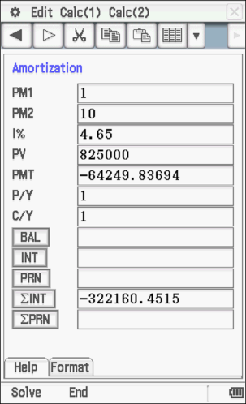

1. If he removes $6,000 per month with interest rate of 5.04% p.a. added monthly, how long will the annuity last and how much will his last withdrawal be?

[3]

1. How much can he remove per year if he wants the perpetuity to last forever?

[2]

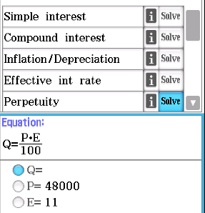

|  |  |
| --- | --- |
| **Compound Interest/Depreciation**  1) Amos invests $32 000 in an account paying 1.85% interest compounded monthly  a) How much interest is earned in 5 years?  b) How long until the investment is worth $40 000?  2) After buying a car for $48 000, Amos finds that after three years it is only worth $27 150. Determine the average rate of depreciation as a percentage. | **Reducing Balance Loans**  Belinda borrows $256 000 over 15 years, with quarterly repayments and interest charged monthly at 5.12% p.a..  a) How much are the repayments?  b) How much interest does she pay over the lifetime of the loan?  c) If she increases her repayments by $500 per quarter, how much will she save in time? How much is her final repayment? |
| **Annuities**  Candice receives $813 000 in her grandfather’s will. She plans to set up an annuity to receive an annual payment of $39 500 for the next 40 years from a financial account paying interest compounded yearly.  a) Determine the interest rate she requires.  b) How much interest does she earn in the first two years?  c) Assuming the interest rate above, for how long will the annuity last of she withdraws $50 000 per year? | **Perpetuities**  Desmond plans to implement a scholarship in perpetuity at his former school paying one student $2 000 per month. How much will he need to invest at 2.85 % p.a. compounded monthly?  **\*Effective Rate of Interest**  What is the effective annual interest rate Desmond will receive? |

|  |  |
| --- | --- |
| **Compound Interest/Depreciation** | **Reducing Balance Loans** |
| **Annuities** | **Perpetuities** |

**3. Graphs and Networks**

**The definition of a graph and associated terminology**

3.3.1 demonstrate the meanings of, and use, the terms: graph, edge, vertex, loop, degree of a vertex, subgraph, simple graph, complete graph, bipartite graph, directed graph (digraph), arc, weighted graph, and network

3.3.2 identify practical situations that can be represented by a network, and construct such networks

3.3.3 construct an adjacency matrix from a given graph or digraph and use the matrix to solve associated problems

**EXAMPLE 15**

1.

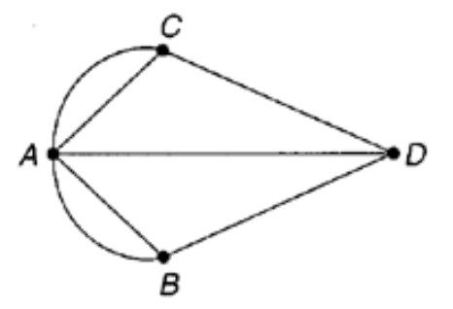

Given the graph above, answer the questions below:

1. List all the vertices.

[1]

1. Add an isolated vertex E.

[1]

1. How many arcs are there?

[1]

1. Clearly label any loops and multiple edges on the graph.

[2]

1. Give a definition of a graph and explain when it becomes a network.

[2]

1. Give the degree of each vertex, A, B, C, D and E.

[2]

1. Are all of the vertices adjacent to each other? Explain.

[2]

2. Create a graph with V = {A, B, C, D, E, F} and E = {AB, BB, AC, AE, CE, DF, DD}

[4]

3. a) Draw a complete graph with 4 vertices, B, E, A and N.

[2]

b) Use the complete graph rule to determine the number of edges in part a).

[2]

4. a) Draw a directed graph that shows B influences E, A and N, E influences A, and A influences N

[2]

b) Are all of the vertices in a) adjacent to each other? Explain.

[2]

c) Draw two subgraphs from the directed graph in part a), showing just the influences on:

[2]

1. N ii) B

5. a) Create a graph with V = {A, B, C, D, E, F} and E = {AD, BE, BC, AE, CF, CE, BF}

[2]

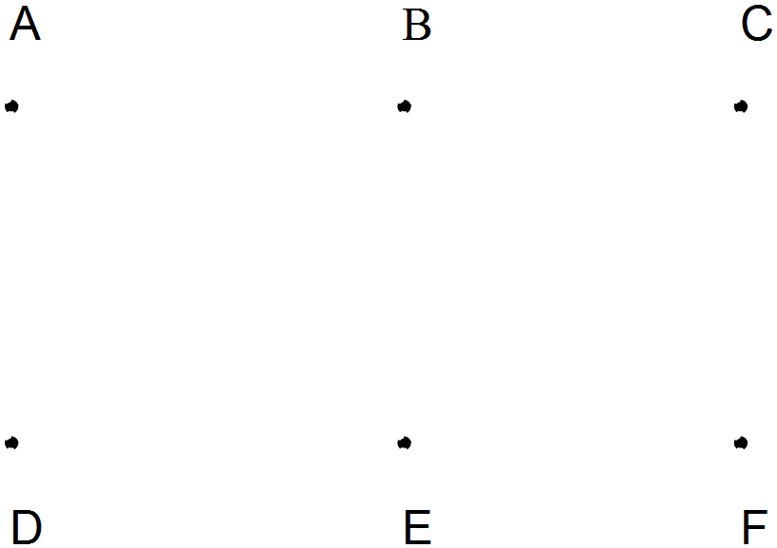

b) Is this graph bipartite? If not, which edge should you remove to make it bipartite? Explain.

[3]

6. Show an example of a graph that is:

a) connected but not simple.

[2]

b) bipartite, but not connected

[2]

**Planar graphs**

* + 1. demonstrate the meanings of, and use, the terms: planar graph and face

3.3.5 apply Euler’s formula, to solve problems relating to planar graphs.

**Paths and cycles**

3.3.6 demonstrate the meanings of, and use, the terms: walk, trail, path, closed walk, closed trail, cycle, connected graph, and bridge

3.3.7 investigate and solve practical problems to determine the shortest path between two vertices in a weighted graph (by trial-and-error methods only)

3.3.8 demonstrate the meanings of, and use, the terms: Eulerian graph, Eulerian trail, semi-Eulerian graph, semi-Eulerian trail and the conditions for their existence, and use these concepts to investigate and solve practical problems

3.3.9 demonstrate the meanings of, and use, the terms: Hamiltonian graph and semi-Hamiltonian graph, and use these concepts to investigate and solve practical problems

**EXAMPLE 16**

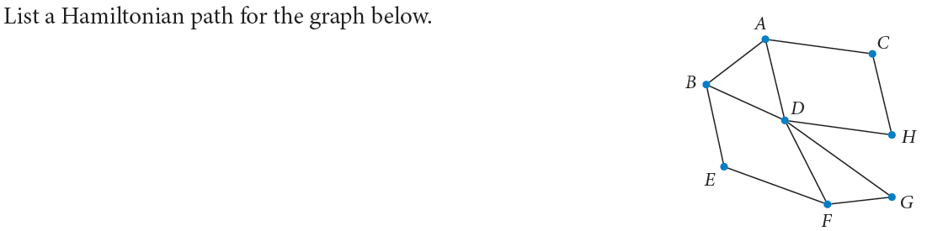

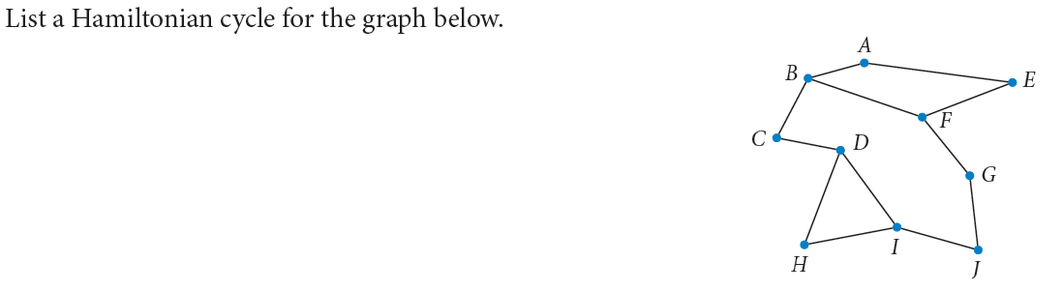

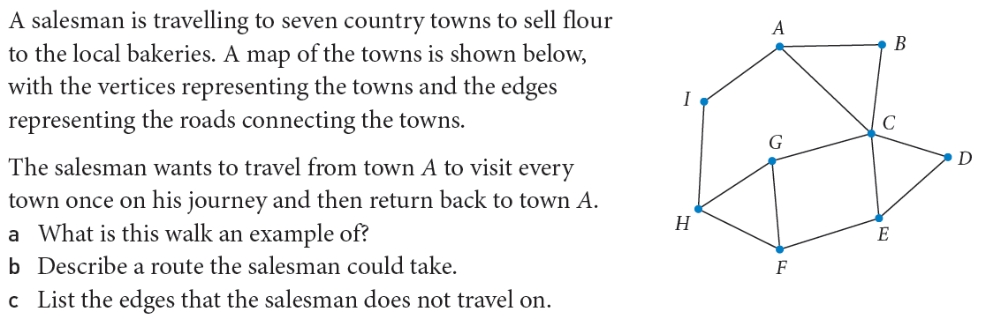

[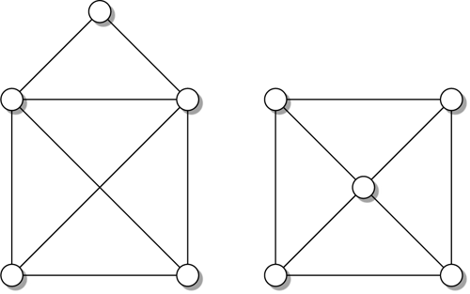](https://www.google.com.au/url?sa=i&rct=j&q=&esrc=s&source=images&cd=&cad=rja&uact=8&ved=0ahUKEwj66MGgjbvMAhXFVZQKHWYEAqkQjRwIBw&url=http://m.oxfordscholarship.com/view/10.1093/acprof:oso/9780199233212.001.0001/acprof-9780199233212-chapter-1&psig=AFQjCNGCdyXhpeyzVN_7uVsdQm2QbLlKOA&ust=1462268292771513) [](https://www.google.com.au/url?sa=i&rct=j&q=&esrc=s&source=images&cd=&cad=rja&uact=8&ved=0ahUKEwj66MGgjbvMAhXFVZQKHWYEAqkQjRwIBw&url=http://m.oxfordscholarship.com/view/10.1093/acprof:oso/9780199233212.001.0001/acprof-9780199233212-chapter-1&psig=AFQjCNGCdyXhpeyzVN_7uVsdQm2QbLlKOA&ust=1462268292771513)

 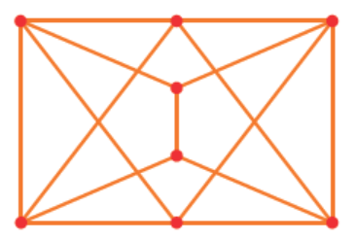

|  |  |  |
| --- | --- | --- |
| **Term** | **Diagram** | **Definition** |
| GRAPH |  |  |
| NETWORK |  |  |
| EDGE/ARC |  |  |
| ISOLATED VERTEX |  |  |
| MULTIPLE EDGES |  |  |
| DEGREE OF A VERTEX |  |  |
| VERTEX |  |  |
|  |  |  |
|  |  |  |
|  |  |  |
|  |  |  |

|  |  |  |
| --- | --- | --- |
| **Term** | **Diagram** | **Definition** |
|  |  |  |
|  |  |  |
|  |  |  |
|  |  |  |
|  |  |  |
|  |  |  |
|  |  |  |
|  |  |  |
|  |  |  |
|  |  |  |
|  |  |  |

**Trees and minimum connector problems**

Trees and minimum connector problems

4.3.1 identify practical examples that can be represented by trees and spanning trees

4.3.2 identify a minimum spanning tree in a weighted connected graph, either by inspection or by using Prim’s algorithm

4.3.3 use minimal spanning trees to solve minimal connector problems

**EXAMPLE 17**

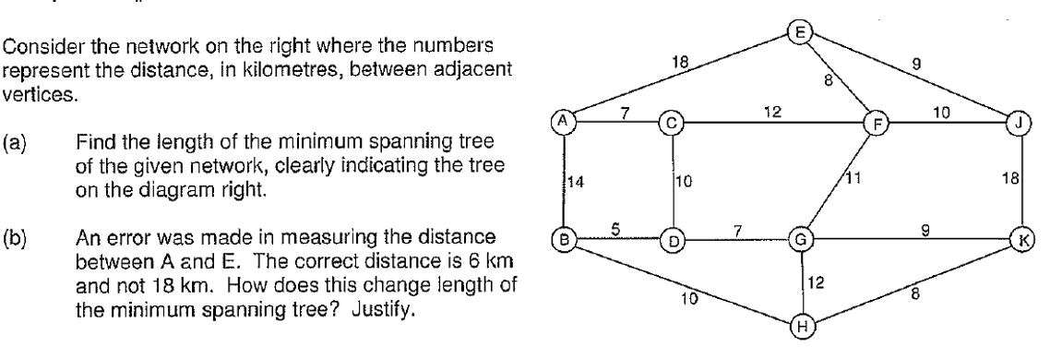

The table below gives the flying distances in kilometres between certain towns.

1. Find the combination of air routes which connects all these towns using the shortest length.
2. Draw the minimum spanning tree indicating the arc lengths.

|  |  |  |  |  |  |  |  |  |
| --- | --- | --- | --- | --- | --- | --- | --- | --- |
|  | Ex | K | MB | N | P | PH | O | W |
| Exmouth | - | 315 | 600 | 605 | 400 | 510 | 110 | 440 |
| Karratha | 315 | - | 320 | 420 | 290 | 195 | 210 | 230 |
| Marble Bar | 600 | 320 | - | 250 | 315 | 153 | 490 | 190 |
| Newman | 605 | 420 | 250 | - | 220 | 365 | 520 | 195 |
| Paraburdoo | 400 | 290 | 315 | 220 | - | 345 | 320 | 130 |
| Port Hedland | 510 | 195 | 153 | 365 | 345 | - | 400 | 220 |
| Onslow | 110 | 210 | 490 | 520 | 320 | 400 | - | 350 |
| Wittenoom | 440 | 230 | 190 | 195 | 130 | 220 | 350 | - |

**Project planning and scheduling using critical path analysis (CPA)**

4.3.4 construct a network to represent the durations and interdependencies of activities that must be completed during the project

4.3.5 use forward and backward scanning to determine the earliest starting time (EST) and latest starting times (LST) for each activity in the project

* + 1. use ESTs and LSTs to locate the critical path(s) for the project
    2. use the critical path to determine the minimum time for a project to be completed

4.3.8 calculate float times for non-critical activities

**EXAMPLE 18**

1. The project below consists of activities A to I.

|  |  |  |  |  |  |
| --- | --- | --- | --- | --- | --- |
| Task | Duration  (days) | Predecessor(s) | Earliest  Start Time | Latest  Start Time | Float  Time |
| A | 10 | - |  |  |  |
| B | 4 | A |  |  |  |
| C | 3 | A |  |  |  |
| D | 10 | B |  |  |  |
| E | 8 | B |  |  |  |
| F | 3 | B |  |  |  |
| G | 7 | C |  |  |  |
| H | 9 | C,F |  |  |  |
| I | 1 | D,E |  |  |  |

1. Draw a project network given the information above.

[3]

1. Determine the critical path and minimum completion time.

[2]

1. Complete the table.

[4]

1. How long can task C be delayed without effecting the minimum completion time?

[1]

2. The project below consists of activities A to J.

|  |  |  |  |  |  |
| --- | --- | --- | --- | --- | --- |
| Task | Duration  (days) | Predecessor(s) | Earliest  Start Time | Latest  Start Time | Float  Time |
| A | 10 | - |  |  |  |
| B | 4 | A |  |  |  |
| C | 3 | A |  |  |  |
| D | 8 | A |  |  |  |
| E | 6 | B |  |  |  |
| F | 9 | B,C |  |  |  |
| G | 3 | D,E,F |  |  |  |
| H | 1 | G |  |  |  |
| I | 2 | D,E,F |  |  |  |
| J | 4 | G,I |  |  |  |

1. Draw a project network given the information above.

[3]

1. Determine the critical path and minimum completion time.

[2]

1. Complete the table.

[4]

1. How long can task E be delayed without effecting the minimum completion time?

[1]

**Flow networks**

4.3.9 solve small-scale network flow problems, including the use of the ‘maximum flow-minimum cut’ theorem

Drainage systems, electricity grids, pipes carrying water and oil and transportation networks (roads, railways, shipping) are concerned with carrying capacity or flow.

The diagram shows a three lane highway in which the two left lanes must merge to cross a bridge.

**Example 19**

The network shows a rail system which connects the towns P and T. The numbers give the maximum

volume of freight (in hundreds of tonnes per day) that can be carried on each section of the system.



1. What is the maximum volume of freight that can be carried from P to T per day?
2. The system needs to be upgraded to increase the capacity by 200 tonnes per day. For practical reasons only one section of the track can be upgraded. Which section should it be?

Find the maximum flow from S to Z through the following network. Which one section could be closed

without affecting this flow?



The example of the network showing a rail system which connected the towns P and T had maximum volume of freight that was 2600 tonnes/day. Use cuts to check this result.



**Assignment problems**

* + 1. use a bipartite graph and/or its tabular or matrix form to represent an assignment/ allocation problem
    2. determine the optimum assignment(s), by inspection for small-scale problems, or by use of the Hungarian algorithm for larger problems

**EXAMPLE 20**

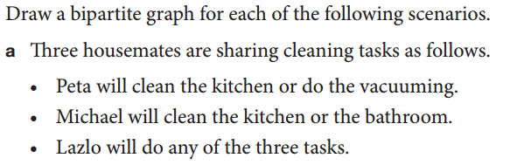

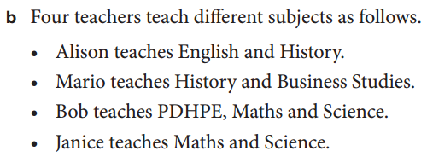

Determine allocations to the four employees:

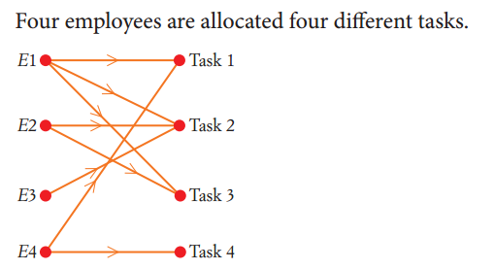

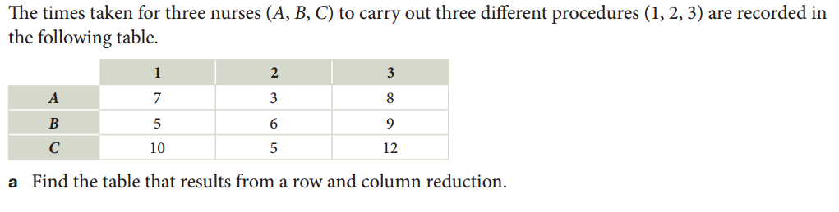

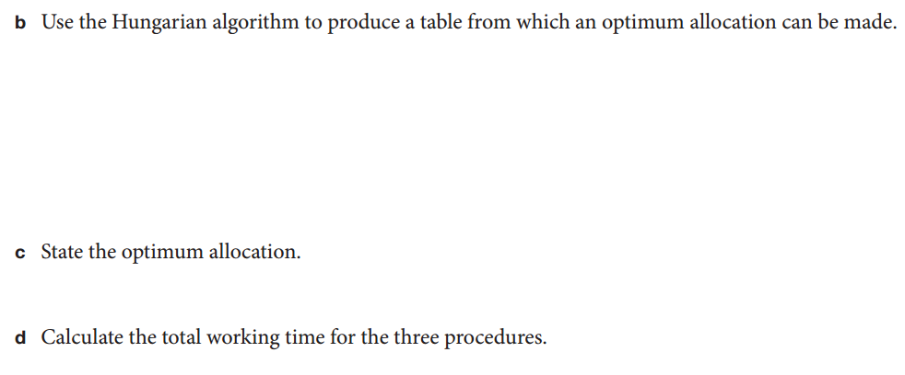

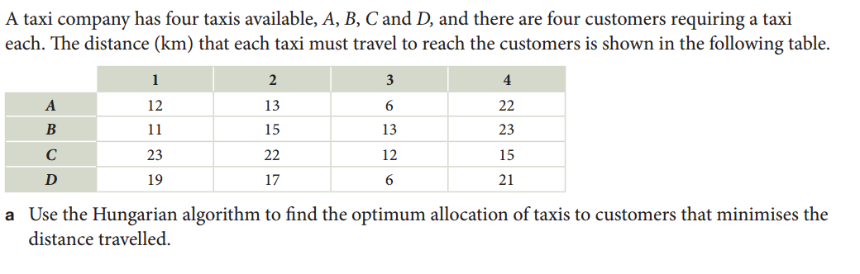



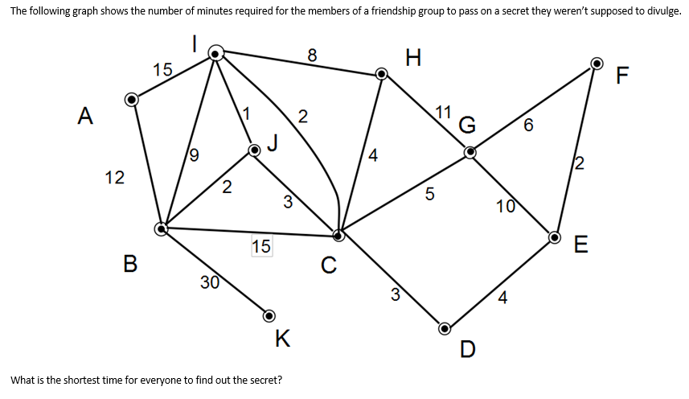

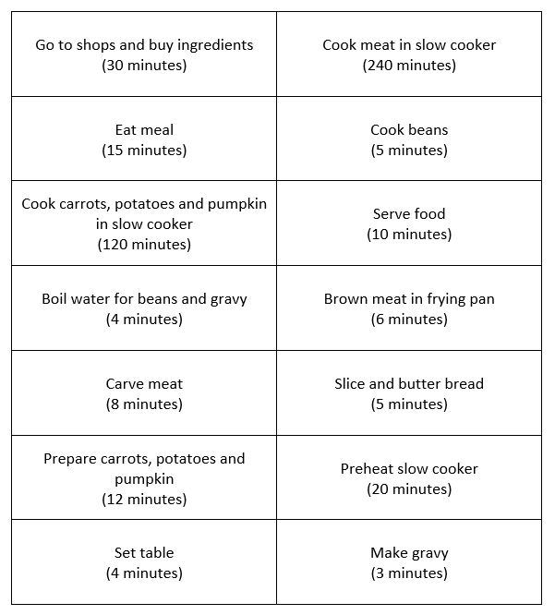

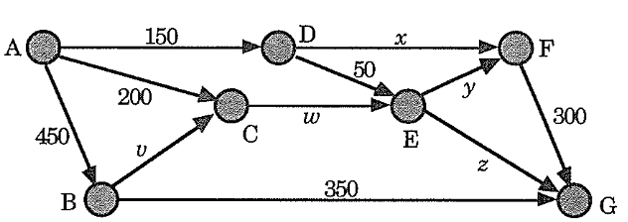

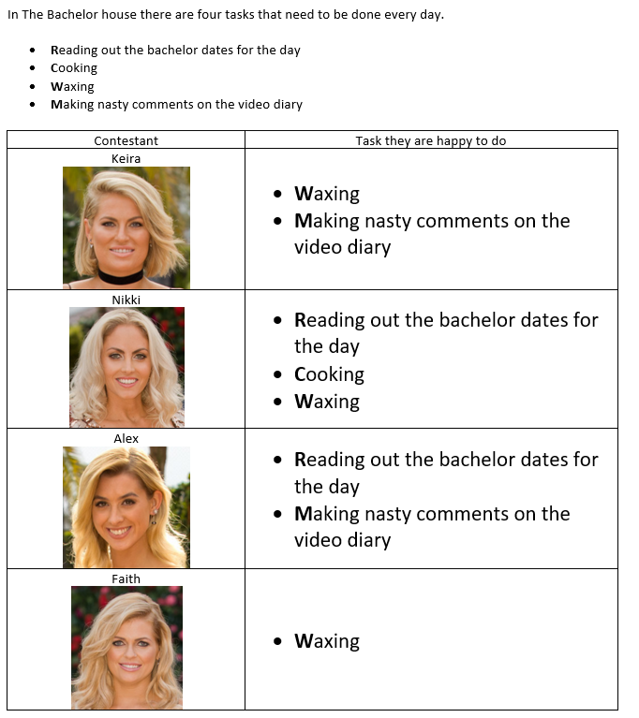

**The BIG Ideas Year 12 Mathematics Applications**

**Statistics 1**

**Sequences 1**

**Networks 1**

**Statistics 2**

**Sequences 2**

**Networks 2**

Congratulations! You have now completed your revision booklet!

Edith Cowan University would like to wish all students the best of luck with their future exams!

