ECU Clinic Space and Research Application Form
Date
School / Research Centre
Title of program, service or research project
Program / service / research study outline | [Provide an outline of the program, service, or research study, including how the Clinic Space and/or Research Principles will be met; goals and outcomes; any external partners, etc.]
Intended usage of clinic space | [Insert information on how ECU Clinic Space will be utilised, e.g. client consultations, service delivery, small group workshops, research studies, etc. For research studies which don’t require access to Clinic Space, write ‘N/A’]
Room/s required | [Insert information on room/s required (see Appendix One: ECU clinic space floor plan). Specify consult room/s, group room/s, offices, and any hot desks required. Specify if the program/project requires special equipment to be used. For research studies which don’t require access to Clinic Space, write ‘N/A’]
Period of access required / research study period | From: | [Include specific times and dates]
 | To:
Project/program staff / research investigators involved | Project / program leader / Chief Investigator |  | [Insert name, position and contact details]
 | Project / program staff / additional investigators |  | [Insert name/s, position/s and contact details. Add other rows as required]
Student involvement | [Insert information on anticipated numbers of students involved, disciplines, and any clinical training or HDR supervision involved]
Services to clients / patients | [Insert information on services to clients, anticipated numbers, and how clients will be managed, e.g. client data and confidentiality, administration support from relevant School, managing noise levels, etc.]
External funding? | Y / N [delete as required]  [Insert name of funding agency and amount of funding provided. If this project/program attracts external funding, will funding be provided to support use of the space?]
Provide a statement addressing the clinical governance and risk profile of the project/program.
[Include confirmation that the relevant School Enterprise and Hazard Risk Registers in RiskWare have been reviewed for strategic/operational risks and WHS hazards related to the activities to be performed at the ECU Health Centre, and have been updated where required.]

FOR RESEARCH STUDIES ONLY:
Participant recruitment | [Insert details of participant recruitment methodology/ies, e.g., utilisation of Research Register, distribution of recruitment material at Centre, approval from Psychological Services Centre Coordinator to utilise PSC client database, if required]
Ethics Committee and approval number | [Insert name of relevant Ethics Committee/s (ECU internal and external, if applicable)]
 | [Insert approval number]

ENDORSEMENT
EnDORSED: …………………………………………………………
[INSERT EXECUTIVE deaN / associate dean (resEarch) and School / research centre here]

DATED: / / 2023

Return completed application form to:
ecuhealthcentre@ecu.edu.au

ECU HEALTH CENTRE COMMITTEE APPROVAL
APPROVED: …………………………………………………………  PROFESSOR MOIRA SIM, Chair, ecu health centre committee  DATED: / / 2023 | Approved  Not Approved

ECU CLINIC SPACE FLOOR PLAN
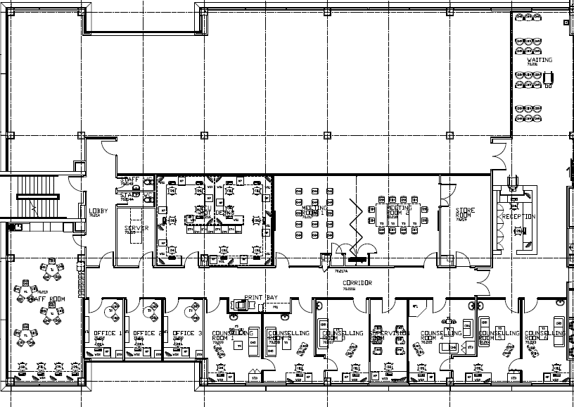
GROUP ROOM #2

GROUP ROOM #1

STAFF ROOM – shared kitchen/lounge for staff, students and ECU Health Centre tenants.
CONSULTING ROOMS
(1, 2, 3, 4, 5, and 6)
Desk and lounge furniture for counselling purposes. Each room has a hand-basin. Viewing Room has a 2-way mirror for observation into consulting rooms 3 and 4.
OFFICES - ECU Psychological Services Centre staff and approved users

3
5
6
4
VIEWING ROOM
1
2
SHARED WAITING ROOM
RECEPTION
Storage Room for records and equipment used in Group Rooms

ECU Hot Desks

11m²
55m²
34m²
34m²
34m²
20m²
20m²
20m²
15m²
23m²
21m²
18m²
13m²
36m²
50m²
36m²
36m²
22m²

This document is to be viewed in conjunction with the document ECU Health Centre Clinic Space Guidelines. Please allow two weeks for the processing of applications.
For risk assessment and management, see ECU’s Integrated Risk Management Framework. For clinical governance resources, refer to the Australian Commission on Safety and Quality in Health Care Clinical Governance.
For School of Medical and Health Sciences applicants only: For non-research related programs and services, approval should be from the relevant Associate Dean (Discipline). For research projects/studies, approval should be from the Associate Dean (Research).

