**1. Data Analysis Answers**

**EXAMPLE 1**

|  |  |  |  |  |
| --- | --- | --- | --- | --- |
|  | > 90 | 80 to 90 | < 90 |  |
| Male | 12 – 17% | 24 – 33% | 36 – 50% | 72 |
| Female | 16 – 15% | 46 – 43% | 46 – 43% | 108 |
|  | 28 | 70 | 82 | 180 |

Little or no association. Females slightly more likely to do better in mid-range scores.

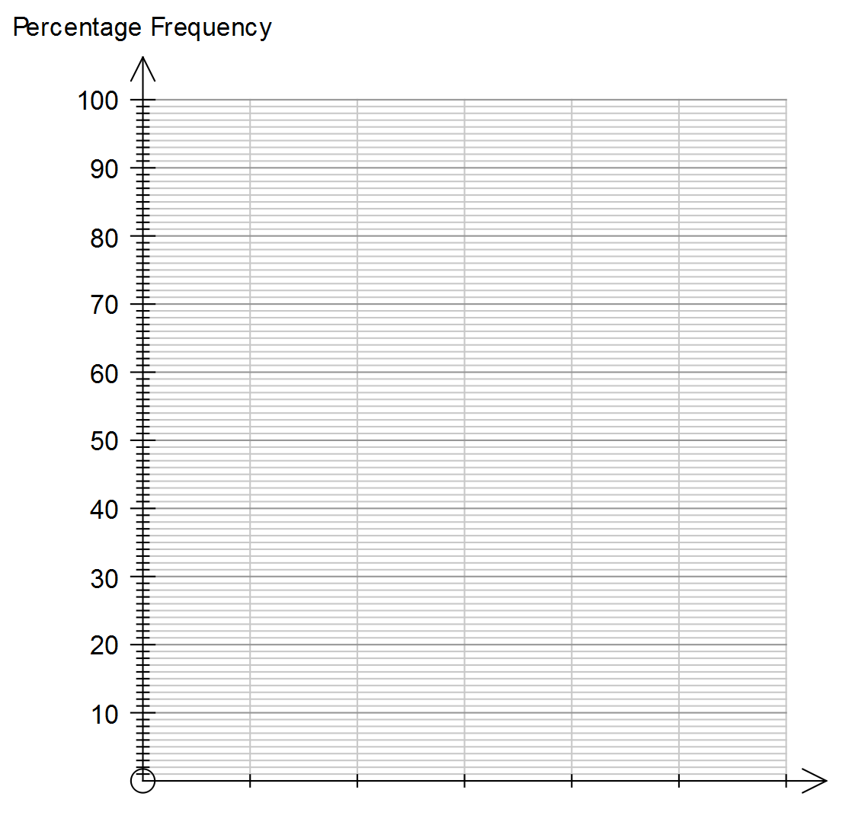



**EXAMPLE 2**

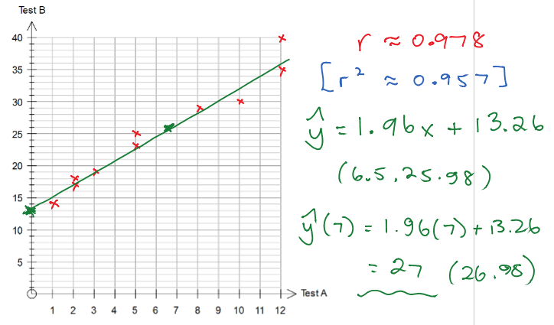

**EXAMPLE 3**

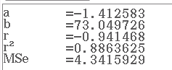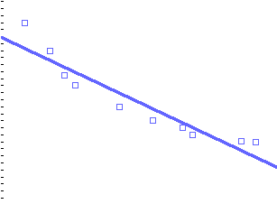

Could be a non-linear relationship.

Residuals would be in a pattern.

**EXAMPLE 4**

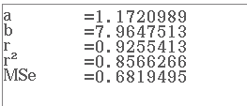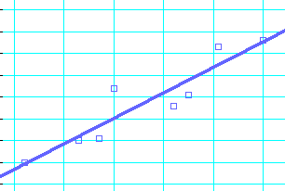

85.7% of the variation in maximum can be attributed to the minimum.

**EXAMPLE 5**

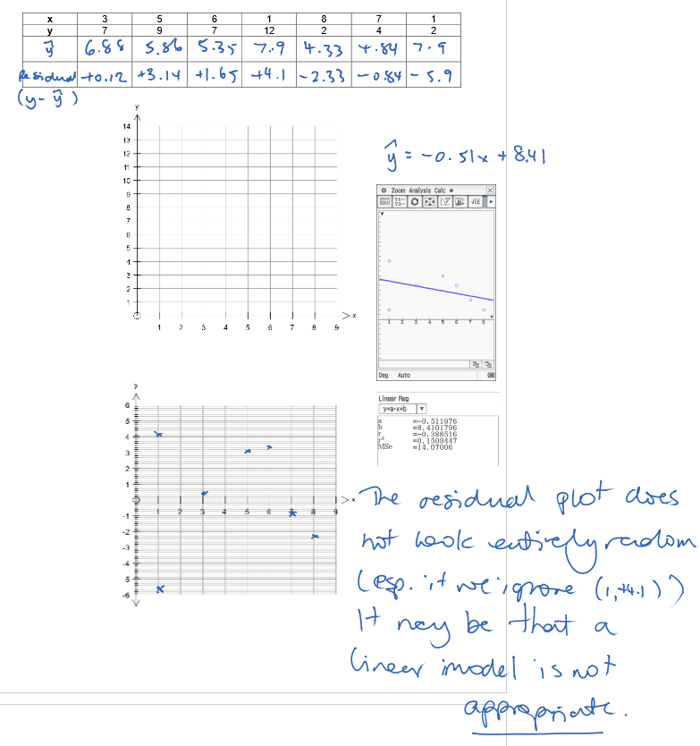

**EXAMPLE 6**



Slight upward trend. Clear seasons every 4 data points ie cycle of 4, period of one year. No irregular fluctuations.

**EXAMPLE 7**

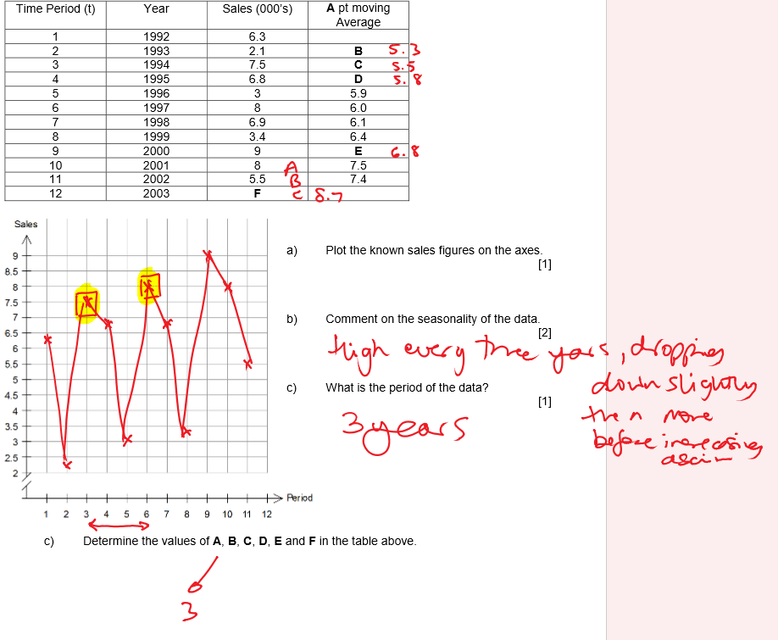

Trend of the data is upwards. A positive, secular trend.

**EXAMPLE 8**

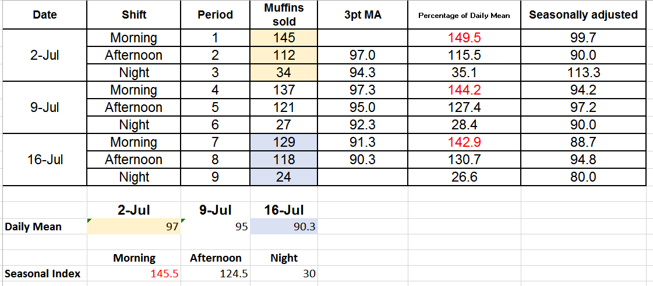

**2. Sequences and Finance Answers**

**EXAMPLE 9**

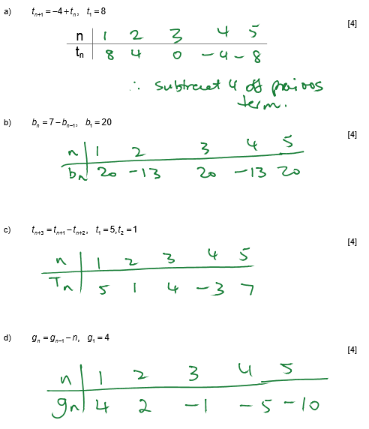

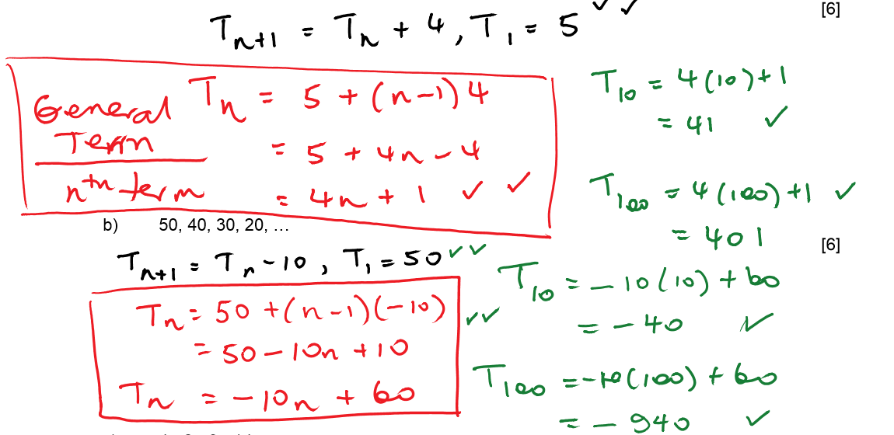

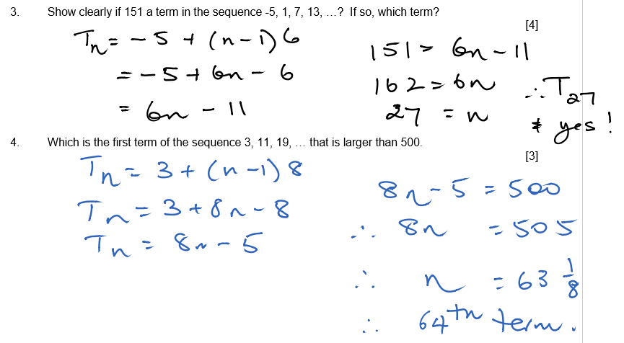

**EXAMPLE 10**

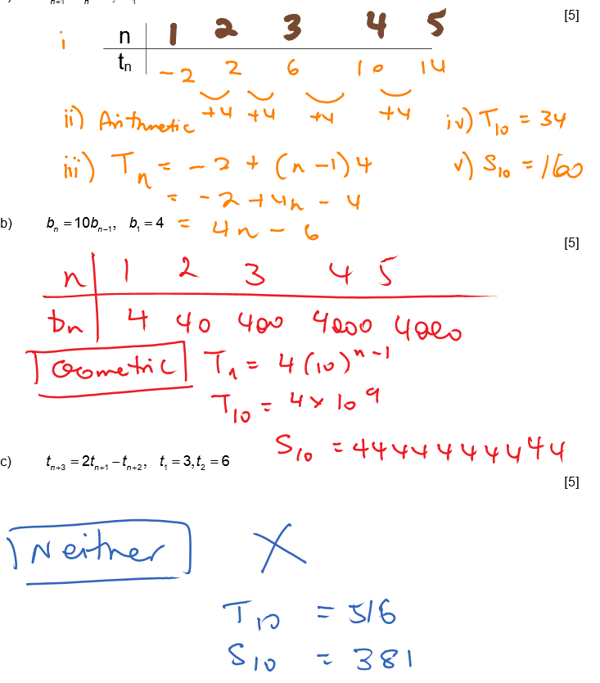

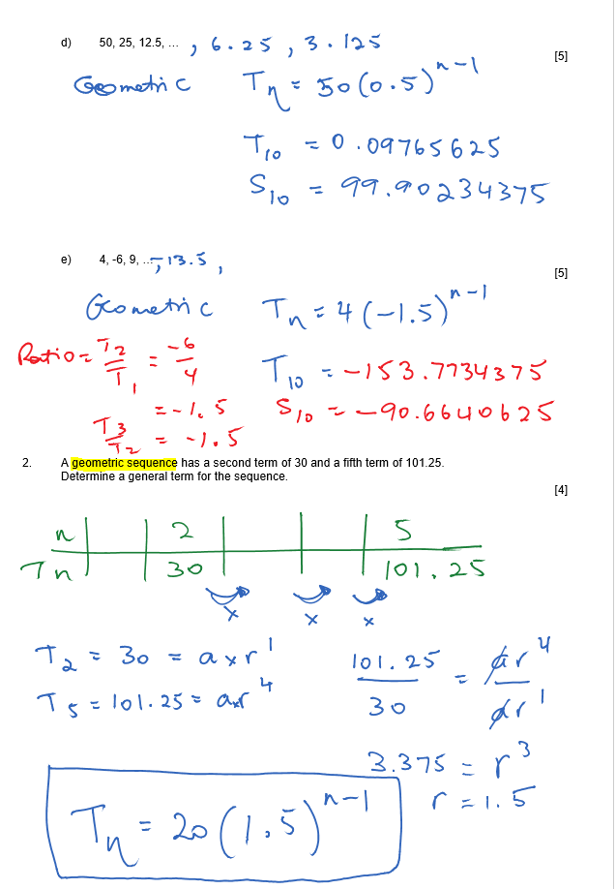

**EXAMPLE 11**

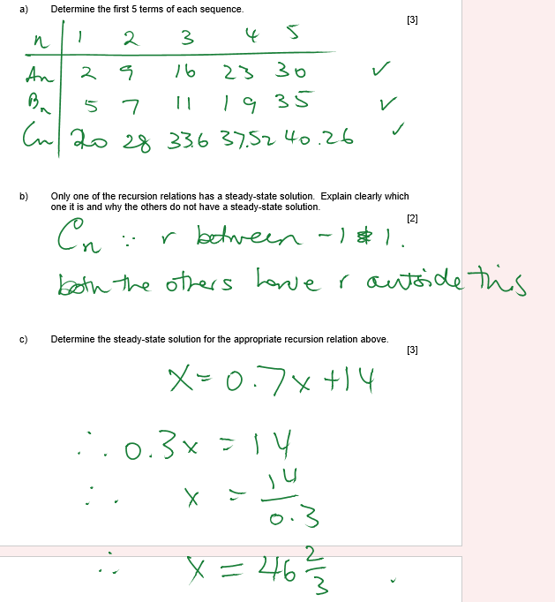

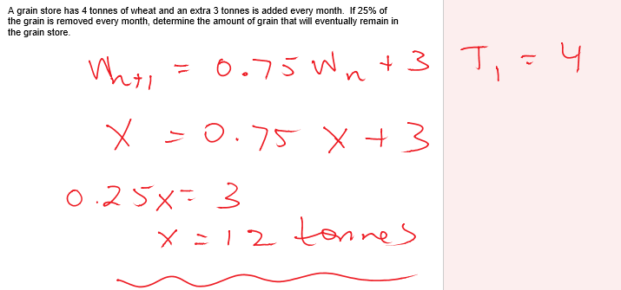

**EXAMPLE 12**

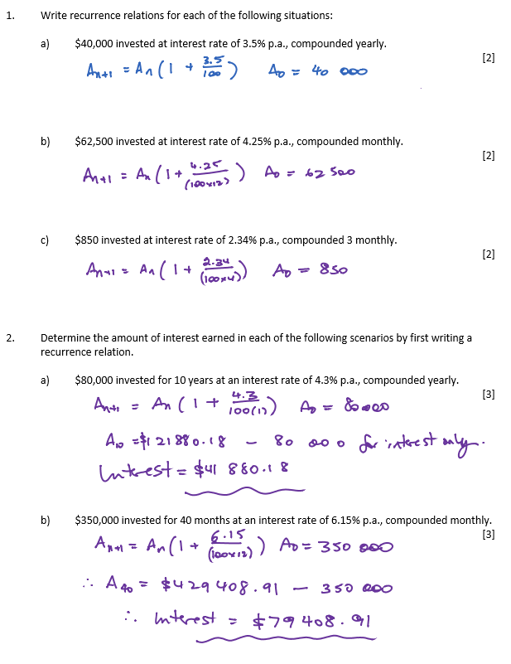

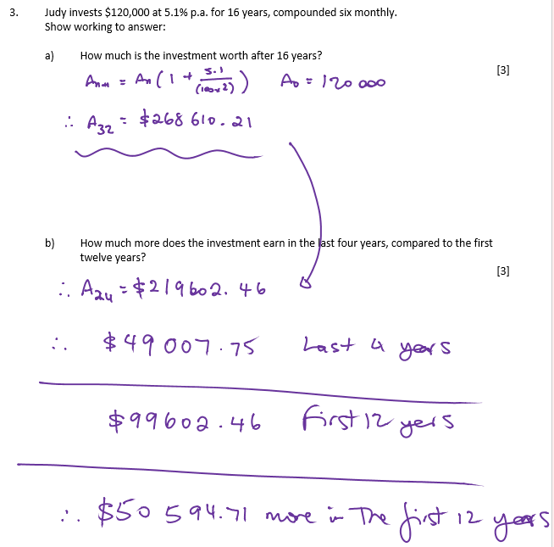

|  |  |  |  |  |  |  |  |
| --- | --- | --- | --- | --- | --- | --- | --- |
|  | n | 5 | Effective | 6.5 | Effective | 11 | Effective |
| Annual | 1 | 105 | 5 | 106.5 | 6.5 | 111 | 11 |
| 6 Monthly | 2 | 105.0625 | 5.0625 | 106.605625 | 6.605625 | 111.3025 | 11.3025 |
| Quarterly | 4 | 105.0945 | 5.094534 | 106.660161 | 6.660161 | 111.462126 | 11.46213 |
| Monthly | 12 | 105.1162 | 5.11619 | 106.697185 | 6.697185 | 111.571884 | 11.57188 |
| Weekly | 52 | 105.1246 | 5.124584 | 106.711571 | 6.711571 | 111.614839 | 11.61484 |
| Daily | 365 | 105.1267 | 5.12675 | 106.715285 | 6.715285 | 111.625957 | 11.62596 |

**EXAMPLE 13**

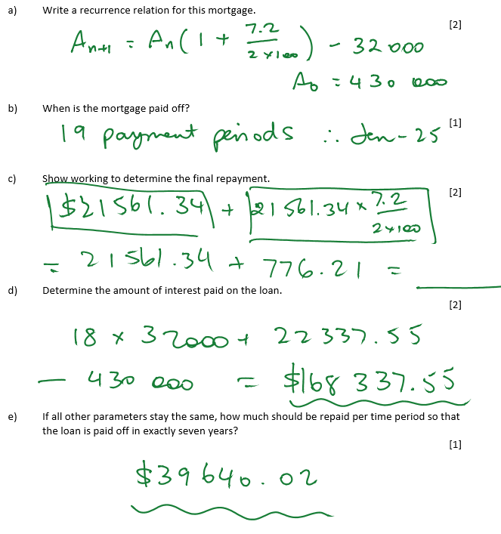

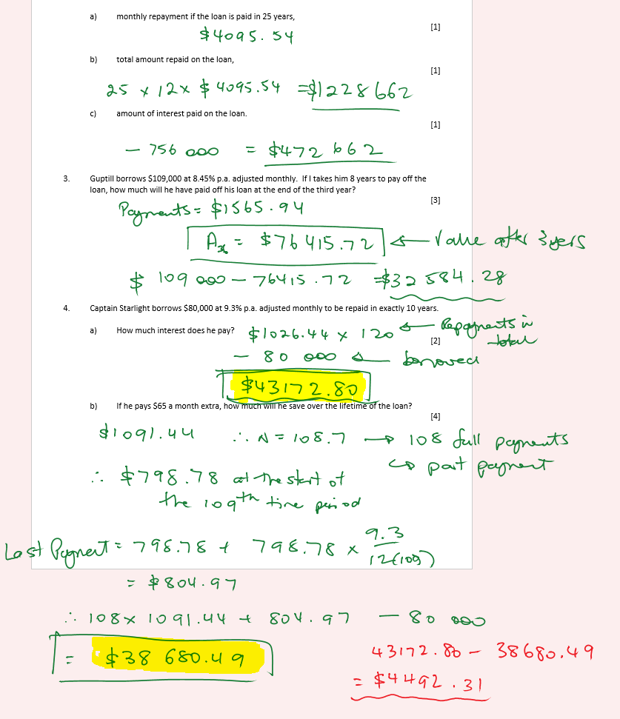

**EXAMPLE 14**

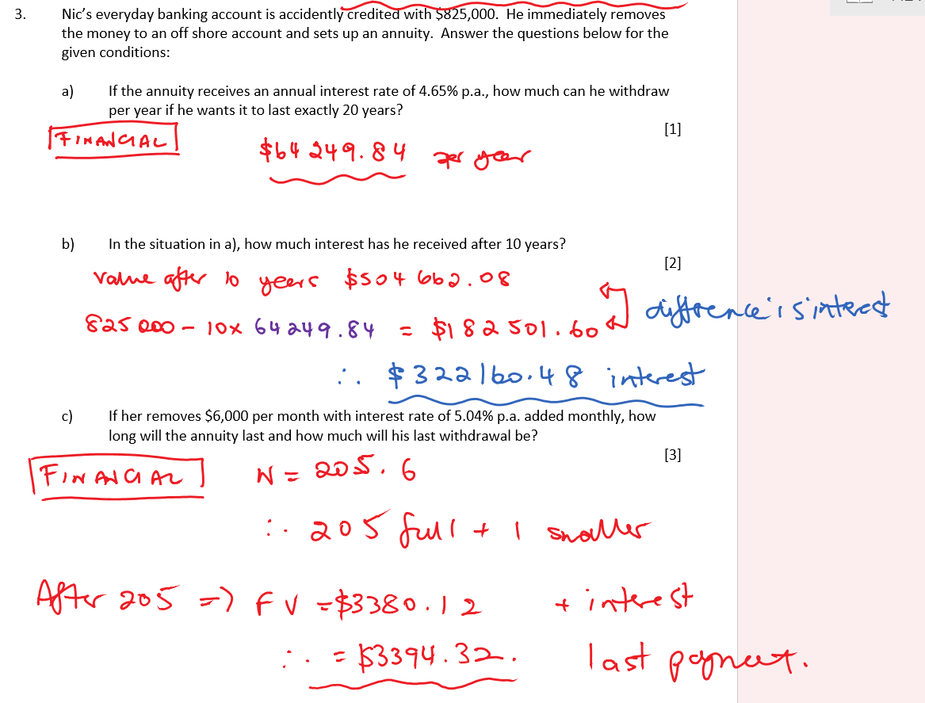

d) **$3465**

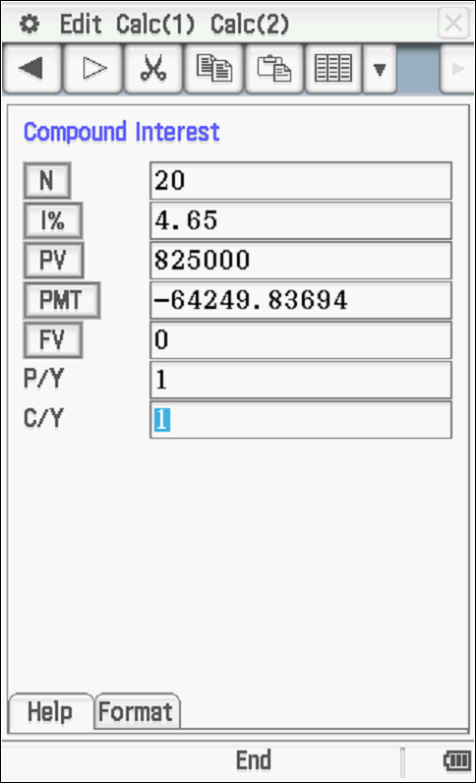 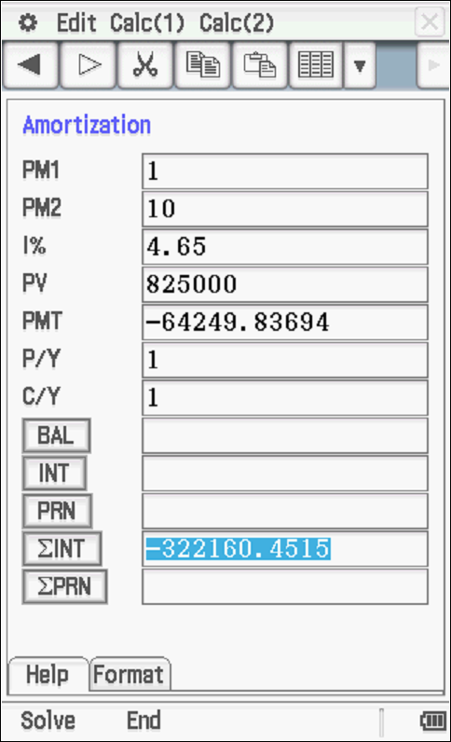

**3. Graphs and Networks Answers**

**EXAMPLE 15**

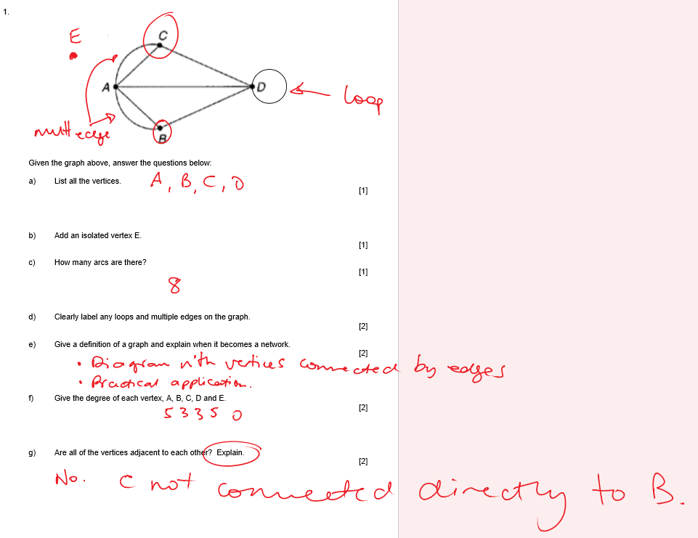 [2]

|  |  |
| --- | --- |
| **Compound Interest/Depreciation**  1) Amos invests $32 000 in an account paying 1.85% interest compounded monthly  a) How much interest is earned in 5 years?  $3098.72  b) How long until the investment is worth $40 000?    2) After buying a car for $48 000, Amos finds that after three years it is only worth $27 150. Determine the average rate of depreciation as a percentage.  17.3% p.a. | **Reducing Balance Loans**  Belinda borrows $256 000 over 15 years, with quarterly repayments and interest charged monthly at 5.12% p.a..  a) How much are the repayments?  6147.57  b) How much interest does she pay over the lifetime of the loan?    c) If she increases her repayments by $500 per quarter, how much will she save in time? How much is her final repayment?  54 payments, 6x3 = 18 months saved  $3297.87 |
| **Annuities**  Candice receives $813 000 in her grandfather’s will. She plans to set up an annuity to receive an annual payment of $39 500 for the next 40 years from a financial account paying interest compounded yearly.  a) Determine the interest rate she requires.  3.74% p.a.    b) How much interest does she earn in the first two years?  $60472.15  c) Assuming the interest rate above, for how long will the annuity last of she withdraws $50 000 per year?  40 | **Perpetuities**  Desmond plans to implement a scholarship in perpetuity at his former school paying one student $2 000 per month. How much will he need to invest at 2.85 % p.a. compounded monthly?  $842105.26  **\*Effective Rate of Interest**  What is the effective annual interest rate Desmond will receive?  2.8875% p.a. |

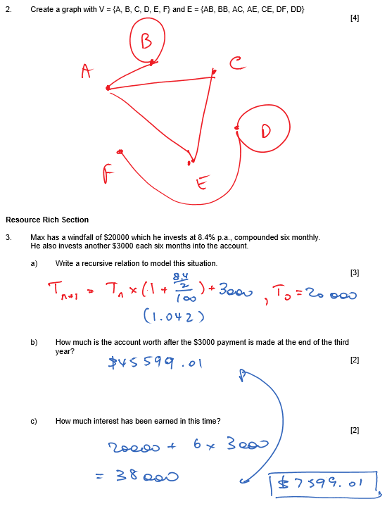

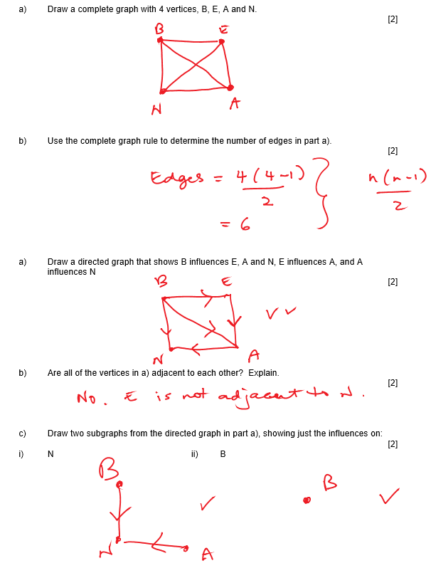



**EXAMPLE 16**

BACHDGFE (Also a cycle)

DHIJGFEABCD

**EXAMPLE 17**

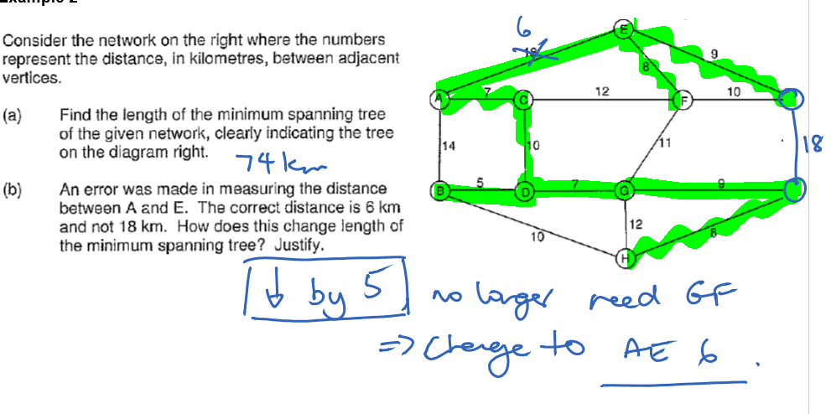

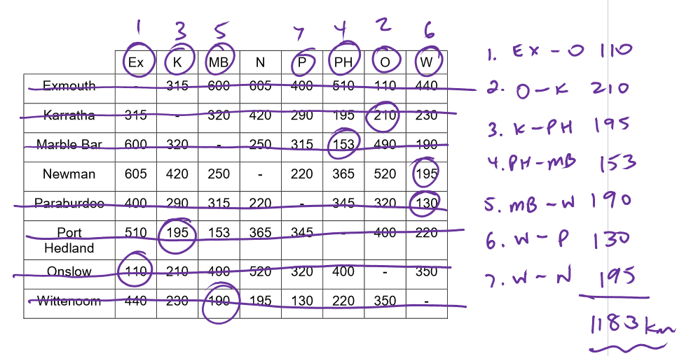

**EXAMPLE 18**

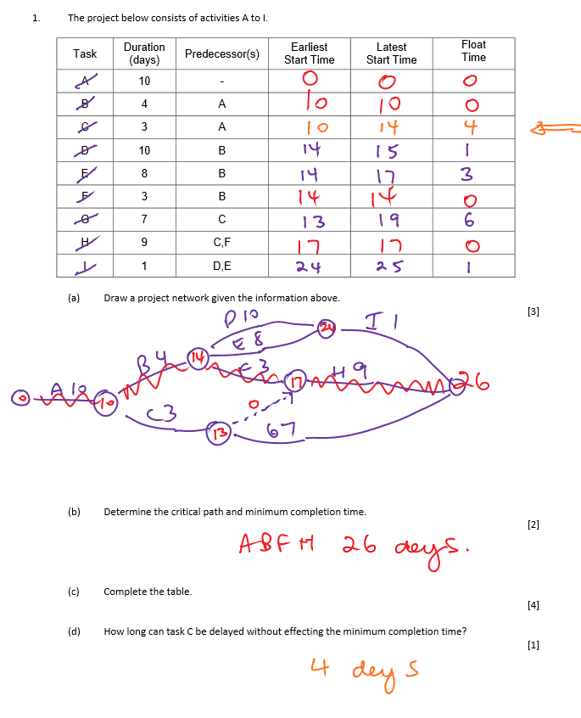

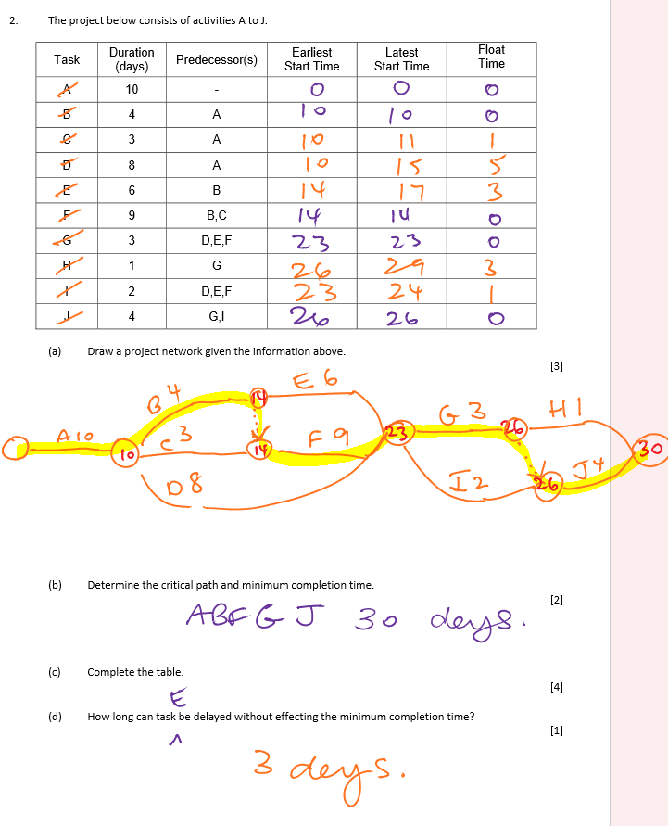

**Example 19**

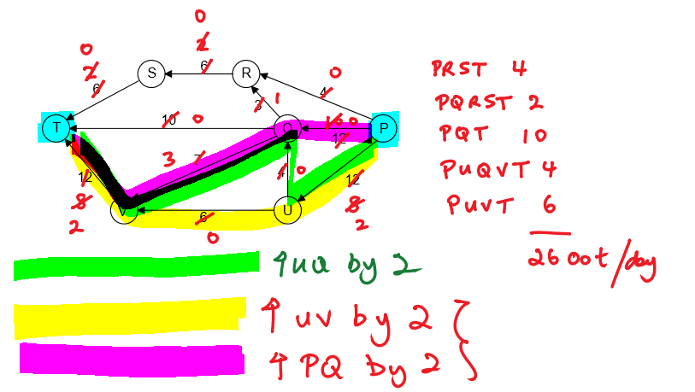

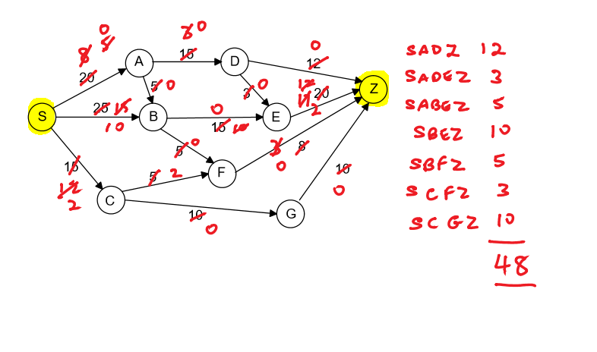

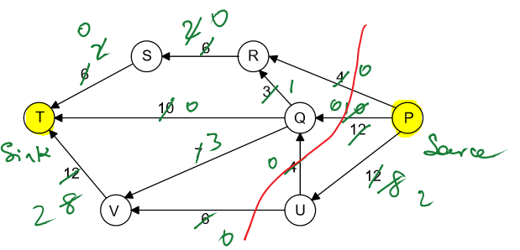

**EXAMPLE 20**

