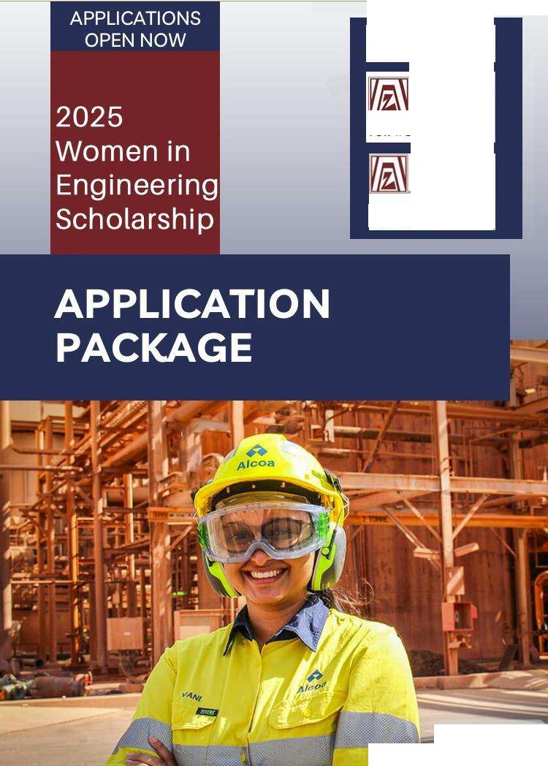

1. **Alcoa**

•• **Foundation**

**ZONTA**

CLU80F

GEELONG INC

1. A BETTER WORLD FOR WOMEN AND GIRLS

**ZONTA**

CLUBOF

PEELINC

BUILD A BETTER WORLDI FOR WOMEN AND GIRLS

**Vani Gupta,** •

**Chemical Engineer**

# Introduction

Zonta clubs envision building a better world for women and girls. This includes empowering young women by promoting, encouraging and assisting them to achieve their goals in courses and/or training for careers in which women are underrepresented.

The number of women studying STEM subjects is increasing; however, women are underrepresented in engineering more so than other STEM disciplines and thus the focus of these scholarships is on civil, electrical, mechanical, chemical and mining engineering.

By recognising and supporting exceptional women, Zonta aims to inspire future generations and to foster inclusivity and diversity in STEM, with particular emphasis on engineering.

# About the scholarship

The Zonta Clubs of Peel and Geelong, in conjunction with the Alcoa Foundation, are pleased to announce ten $1,500 scholarships available for women between 18 and 35 years living in either Western Australia or Victoria and studying engineering.

The purpose of the award is to promote, encourage and assist young women to achieve their goals in courses and/or training that will lead to careers in which women are under-represented.

Both the Zonta Clubs of Peel and Geelong and The Alcoa Foundation anticipate that the scholarships will increase engagement amongst women studying engineering by assisting them with the affordability of their educational needs.

# Eligibility

The scholarships will be awarded to women between 18 and 35 years for tertiary study in a university or technical college course in Victoria or Western Australia, where engineering is a major component.

Applicants should be current Victorian or Western Australian residents presently enrolled in a course in the engineering field. Proof of enrolment is required.

# Applications

Applicants will be required to provide:

* details of relevant demographics, academic background, employment history (if applicable), awards and honours received, volunteer and other activities, and a confidential academic referee.
* study and professional goals
* how scholarship funds will be used.

Applicants must sign the:

* Alcoa Photograph/Filming Consent Form:
* Alcoa/Zonta Data Protection Declaration

# Selection Criteria

1. The candidate must be a female tertiary student aged between18 to 35 years, who is an Australian citizen or permanent resident and currently resides in either Western Australia or Victoria.
2. They must be currently undertaking their second year or beyond of a tertiary level course (university or TAFE) in which engineering is a major component.
3. High achievement in a tertiary level course in the engineering field.
4. The candidate displays a deep interest and knowledge of engineering.
5. The candidate is extremely positive and passionate about a career in engineering.
6. The candidate shows an understanding and commitment to the role of women in engineering.
7. The tertiary institution (professor/lecturer/faculty member) provides an academic reference for the candidate's application in relation to the purpose of the award.
8. The candidate, if successful, must be available to attend presentation/club events in either Mandurah, for Western Australian applicants, or Geelong, for Victorian applicants.
9. The applicant must complete the enclosed:
   * Application
   * Verification of Current Enrolment (proof of enrolment)
   * Alcoa Photograph/Filming Permission Form
   * Alcoa/Zonta Data Protection Agreement

**Enquiries to:**

**Zonta Club of Peel (for Western Australian Applicants):**

**Mailing address: PO Box 275, Mandurah WA Email:** [**zontapeel@yahoo.com**](mailto:zontapeel@yahoo.com)

**Facebook: Zonta Club of Peel Inc**

**Zonta Club of Geelong (for Victorian Applicants):**

**Email:** [**zontaclubofgeelong@yahoo.com.au**](mailto:zontaclubofgeelong@yahoo.com.au) **Facebook: Zonta Geelong**

**lnstagram: zontageelong**

**Website:** [**www.zontageelong.org.au**](http://www.zontageelong.org.au/)

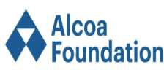  

2025 Women in Engineering

Scholarship

Application Form



Name of university or TAFE currently attending

Address

**Applications close at 5pm Sunday 30 November 2025 (WA & Vic time).**

**Application Questionnaire**

Academic background

Applicants are required to provide transcripts of grades or equivalent records from all universities, colleges or institutes attended. An explanation of the grading system must be included for each transcript. Please add your degree obtained or current degree sought, if applicable, an expected graduation date (month/year). Unofficial transcripts will not be accepted.

I

|  |  |  |  |
| --- | --- | --- | --- |
| University/college/institute/online I (Year) to (Year) I Major Field I Date degree received/Anticipata:I | | | |
|  |  |  |  |
|  |  |  |  |
|  |  |  |  |
|  |  |  |  |
|  |  |  |  |
|  |  |  |  |

|  |  |  |  |  |  |
| --- | --- | --- | --- | --- | --- |
| **Em** | oyment history (if ap | | icable) | | |
| From (month/year) | | To (month/year) | Name of Employer | Address | Type of work or position held |
|  | |  |  |  |  |
|  | |  |  |  |  |
|  | |  |  |  |  |
|  | |  |  |  |  |
|  | |  |  |  |  |

Scholarships, awards and honours received **(if** applicable)

Date

Volunteer and/or other activities

I I I I

Recommendations

Please use the following fields to name and send a recommendation letter request to a faculty member in the engineering field. These recommendations are confidential and you will not be privy to the completed responses. It is the responsibility of the applicant to make sure these recommendations have been turned in by the Zonia club's deadline.

Please list below the referees who will submit a recommendation:

Name Position Title College/University/institute











How would the Zonta Women in Engineering scholarship assist you in achieving your academic goals:



Please complete and attach the following documents to your submission:

* Verification of Current Enrolment Form (proof of enrolment)
* Zonta/Alcoa Foundation Photograph/Filming Consent Form
* Zonta Data Protection Agreement

Please return your completed application and attachments to:

* For Western Australian applicants:

[zontapeel@yahoo.com](mailto:zontapeel@yahoo.com)

* For Victorian applicants:

[zontaclubgeelong@yahoo.com.au](mailto:zontaclubgeelong@yahoo.com.au)

  

**Zonta Data Protection Agreement**

### Please read the following information carefully and indicate your agreement as appropriate.

1. Most data collected by the Zonta Clubs of Peel and Geelong is used only to help Zonta better serve its scholarship recipients. It is their general policy to collect and store only personal information that applicants knowingly provide. Zonta does not sell, trade or rent personal identifying information to third parties. Except as described in paragraph two, Zonta Clubs of Peel and Geelong take reasonable measures not to disclose personally identifying information about applicants.
2. To ensure the Zonta Clubs of Peel and Geelong's ability to fund the scholarship, the Clubs may from time to time provide information to co-sponsors about recipients of their donations. Zonta retains the right to use your name, photograph and biographical information to promote the Zonta Women in Engineering Scholarship in various promotional materials including our website.

I have read the information about data collection and agree to the Terms and Conditions therein.

Signed:

### Declaration

I certify that all the information contained in my application form is accurate to the best of my knowledge.

Signed: Date:

### Please note:

1) Zonta will extend an invitation to Scholarship recipients to attend a Zonta meeting to update the Club on their academic achievements and role in the field of engineering.

  

Zonta/ Alcoa Foundation

Photograph/Filming Consent Form

This consent form is used by the Zonta Clubs of Peel and Geelong and the Alcoa Foundation to obtain permission from people not employed by the company to be photographed at Alcoa Foundation sites or sponsored events.

The undersigned agrees all photographs, footage and/or audio recordings are the copyright of Alcoa Foundation and Zonta Clubs of Peel and Geelong and will be held on file until Alcoa Foundation and Zonta Clubs of Peel and Geelong chooses to delete them.

The undersigned also understands photographs, footage and/or audio may be used by Alcoa Foundation and Zonta Clubs of Peel and Geelong for promotional purposes and publications including, but not limited to, reports, newsletters, brochures, advertising, websites and print, broadcast and social media.

### I hereby give permission to be photographed, filmed and/or have my voice recorded by Alcoa Foundation and Zonta Clubs of Peel and Geelong and agree with the above ownership and usage conditions.

|  |  |
| --- | --- |
| **Name:**  (Block letters) |  |
| **Address:**  (Block letters) |  |
| **Post code:** |  |
| **Telephone:**  (Mobile preferred) |  |
| **Signature:** |  |
| **Date:** |  |

**Office Use Only:**

|  |  |
| --- | --- |
| **Photo Shoot Date:** | |
| **Event/ Purpose:** | |
| **Alcoa Site** *I* **Event Location:** |  |
| **Participating Organisation: (if applicable)** |  |
| Alcoa **SPA:** |  |
| Photographer: |  |
| Images located at: | |

  

**Zonta Verification of Current**

**Enrolment Form**

## Verification of Current Enrolment Form for Zonta Women in Engineering Award

I certify that is currently enrolled in

(name of student)

in

(year of degree program) (name of course/degree being studied)

at

(address college/university/institute)

(signature of college/university/institute official)

(official stamp of the college/university/institute)



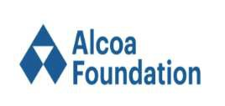

Recommendation for the Women in Engineering Award

**Please return this form by: Sunday 30 November 2025 (5pm WA or Vic time)**

Applicant:

Last (Family) Name First Middle

Recommendation

from: Name Position/Title

College/university/institute

The applicant above has applied for a Zonia Women in Engineering Award. The Zonia Clubs of Peel and Geelong, along with the Alcoa Foundation greatly values and appreciates your opinion. Please discuss the applicant's accomplishments; current academic program and/or work experience; intellectual independence; capacity for analytical thinking; ability to organise and express ideas clearly; creativity; motivation; and potential for advancing knowledge and innovation in an engineering field. You may write your recommendation letter on letterhead of your choice, but you must sign and submit the letter with this form.

How well do you know the applicant? Please rate the applicant with respect to your experience with other students in this field:

     

Exceptional Top 5%

Very Good Next 10%

Good Next 15%

Average Next 30%

Below Average Last 40%

Insufficient opportunity to observe

Referee's signature is required (Insert image of your signature or print, sign and scan this page.) Date

**Please return this form along with your recommendation letter to:**

**For Western Australian residents:**

Zonta Club of Peel

email:[**zontapeel@yahoo.com**](mailto:zontapeel@yahoo.com)

**For Victorian residents:**

Zonta Club of Geelong

email: [**zontaclubgeelong@yahoo.com.au**](mailto:zontaclubgeelong@yahoo.com.au)

**o**



**co--**

**da**



U OF

C.1 · GI _C

B



·: _ . 0

_,_



A_

--

I L51

**ZONT'A**

C USO PEEL IN,c

8Ul1LD **A,B** - E : WORLD FOR WO,MEN A--_,D GIRLS